**Student Assessment Submission and Declaration**

When submitting evidence for assessment, each student must sign a declaration confirming that the work is their own.

|  |  |  |  |
| --- | --- | --- | --- |
| Student name: Vajresh Patkar | | Assessor name: Aniket | |
| Issue date: 3 Jul 2019 | Submission date: 24 Jul 19 | | Submitted on: |
| Programme: Pearson BTEC Level 5 HND in Application Development | | | |
| Unit: 4 Web Design and Development | | | |
| Assignment number and title: 1 of 2: Development of website for a Training Organization – Part 1 | | | |

**Plagiarism**

Plagiarism is a particular form of cheating. Plagiarism must be avoided at all costs and students who break the rules, however innocently, may be penalised. It is your responsibility to ensure that you understand correct referencing practices. As a university level student, you are expected to use appropriate references throughout and keep carefully detailed notes of all your sources of materials for material you have used in your work, including any material downloaded from the Internet. Please consult the relevant unit lecturer or your course tutor if you need any further advice.

**Student Declaration**

|  |
| --- |
| **Student declaration**  I certify that the assignment submission is entirely my own work and I fully understand the consequences of plagiarism. I understand that making a false declaration is a form of malpractice.  Student signature: nhwksh Date: |

Table of Contents

1. DNS 6

❖ Intro 6

❖ Why We Use It? 6

❖ DNS Elements 6

❖ DNS Types 7

❖ How Does It Work 7

❖ Live Configuration 8

2. Protocols 10

❖ Intro 10

❖ Why We Use It? 10

❖ Common Protocols 10

❖ Port Number 11

3. Server Hardware 13

❖ Intro 13

❖ Rack Mount 13

❖ Tower 14

❖ Blade 14

❖ Components 15

❖ Types of servers 16

❖ Server Specifications 16

4. Operating System 18

❖ Intro 18

❖ Windows server 18

❖ Windows OS 18

❖ Mac OS 18

❖ Android 18

❖ Linux 19

5. Website Designing 20

❖ Intro 20

❖ Wire-frames 20

❖ Information Architecture 25

❖ Storyboard 25

❖ Website Implementation 26

6. Web Server Software 27

❖ Intro 27

❖ Apache HTTP server 27

❖ Apache Tomcat 28

❖ Nginx 29

❖ Oracle HTTP server 29

7. How Website Work? 30

❖ Intro 30

❖ Front-end 30

❖ Back-end 37

❖ Comparison 39

❖ Website Working at Layers Level 39

8. Tools for building Website 41

❖ Intro 41

❖ Website Generators 41

❖ Custom Building From scratch 47

❖ Comparison 50

9. Changes over the years 52

❖ History of Web 52

❖ Responsive Design 53

❖ Single Page Applications 54

10. Search Engine Optimization(SEO) 55

❖ Intro 55

❖ How does SEO works? 55

❖ Factors that affect the ranking and how to improve it. 55

11. Tools for custom website development 58

❖ Intro 58

❖ Available Tools 58

❖ Tools I Used 59

12. Bibliography 62

# DNS

## Intro

* DNS stands for Domain Name Services or Domain Name System.
* They are like the phone book of Internet where instead of phone number and person name pair they have IP Addresses and Domain Name pairs.
* For example, the domain name google has 172.217.166.78 IP address.(type anyone in browser and you will be redirected to google’s homepage).

## Why We Use It?

* We human are not good at remembering long numbers while computer were not designed to work with name.
* So to solve this communication issue, developers came up with DNS where humans enter name and server receives IP address.

## DNS Elements

* Any DNS server has at least 3 elements name-space, name server and resolver.
* Name-space
  + The name-space save names in a tree like structure where at the end of each node is different domain along with records containing host name, IP address and other necessary details.
  + Query options are used to retrieve records from specific domain.
* Name Server
  + The name server is mechanism that store information about domain tree structure.
  + It also contains authoritative details of one or more domains.
  + Name server responds to queries about domains it has authority over.
  + If it doesn’t have authority, then it forwards the query to correct name server.
  + It allows DNS to access relevant information about domains in the tree
* Resolver
  + Resolver is client side program that generates the query and send to DNS server.
  + A resolver typically has direct access to at least one DNS server.

## DNS Types

* Root name servers
  + These are the default DNS name server to be queried if the name is not resolved.
  + It returns authoritative name server IP address.
* Top Level Domain (TLD) Server
  + It is responsible top level domains like com, org and country domains like fr, in, ca, etc.
  + They have details about authoritative domain servers and know names and IP address of each authoritative name server for second level domains.
* Authoritative Server
  + This is organization’s DNS server providing authoritative host name to IP mapping for organization server.
  + It is maintained by organization or ISP(internet service provider).

## How Does It Work

* The client access a URL via browser. If the resources are not already cached in the memory, the resolver generates a query and send to root name server.
* The root name server sends the IP address of TLD to the resolver.
* The resolver then queries the TLD and receives IP address of authoritative server.
* The resolver then queries authoritative server which send the IP address of domain.
* The resolver sends the IP to the client. The client asks for the files and website is displayed in the clients machines.
* All this steps takes within seconds.

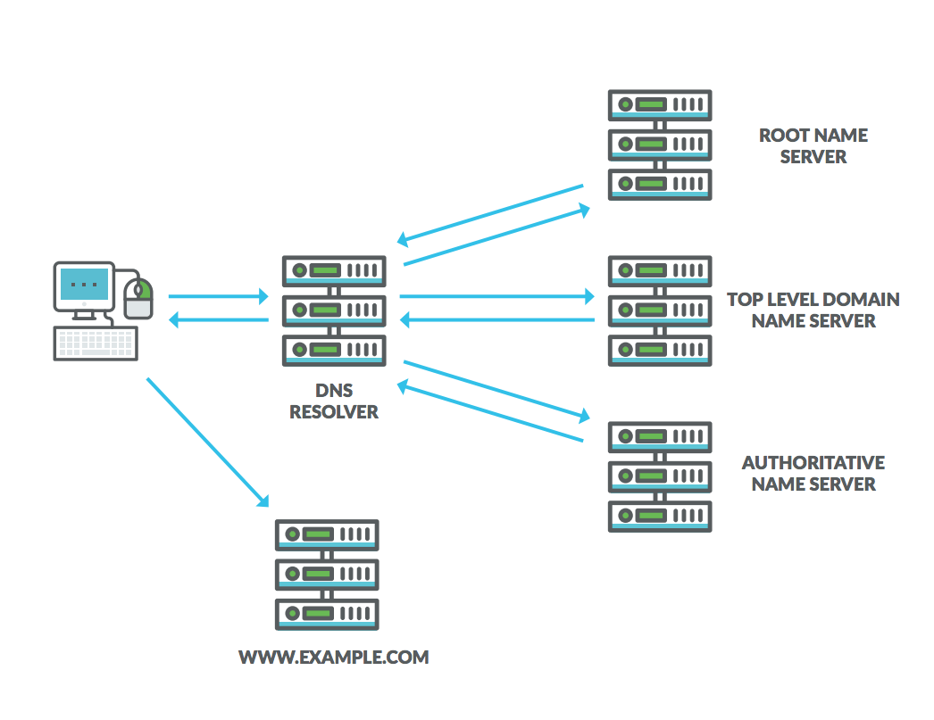

## Live Configuration

* To configure a Domain name we will use noip.com website.
* These are the steps to create your domain name for free which will be active for 30 days.
* Sign In the website and create a account.

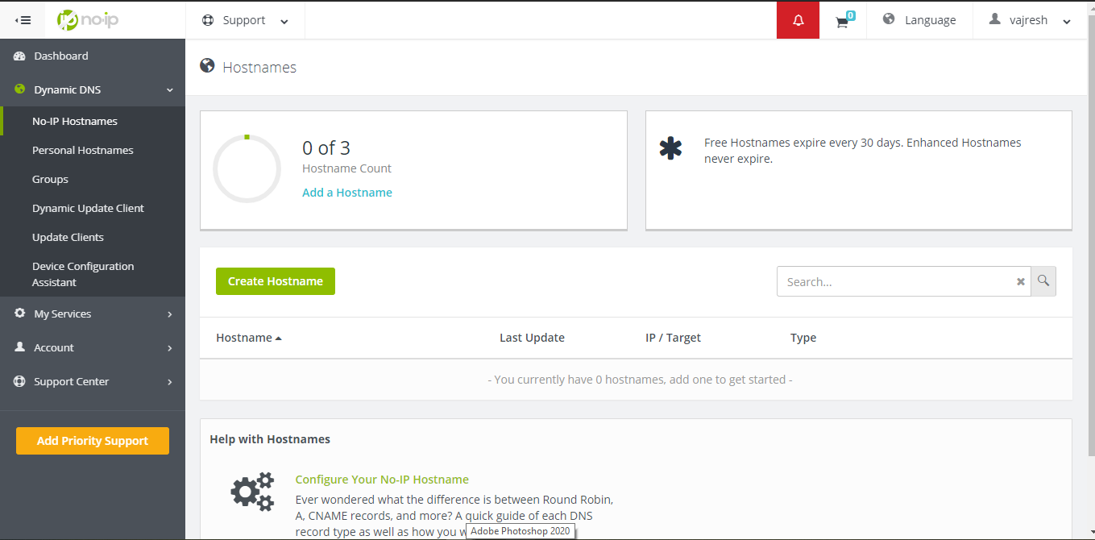

* Navigate to create host name and create one by entering details.

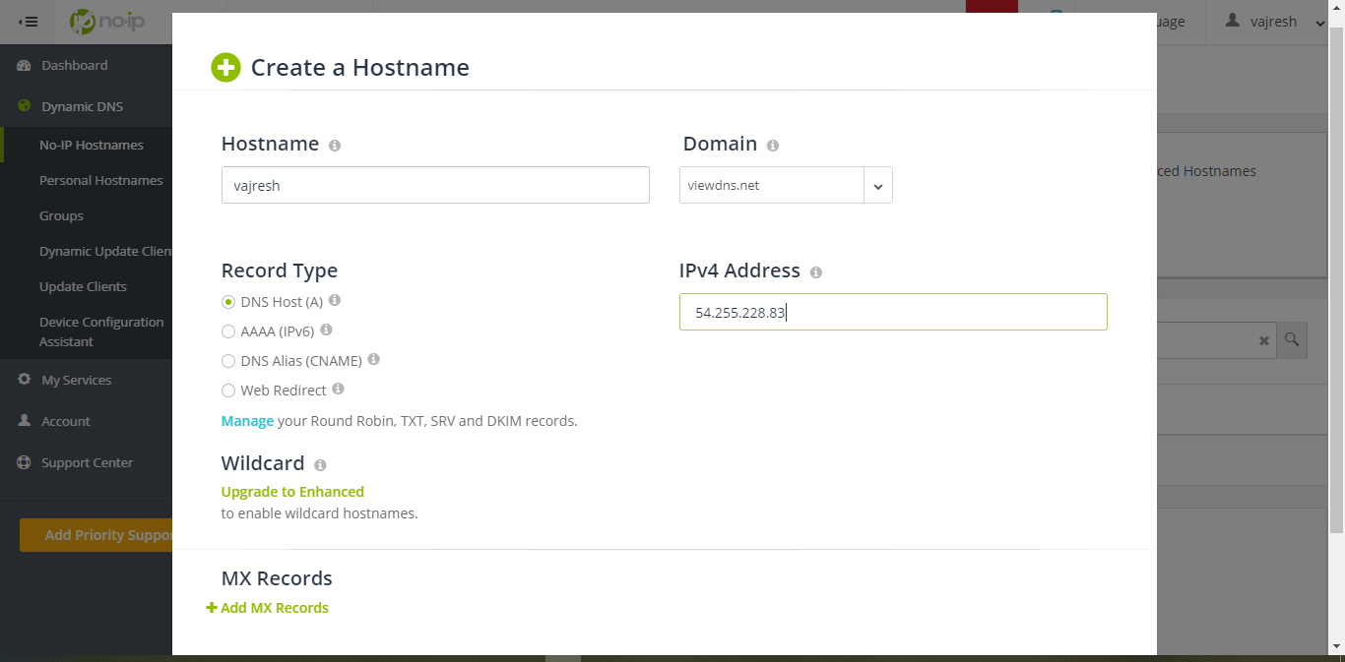

* Go to a new tab and enter your host name and you will see the website linked to your host name.

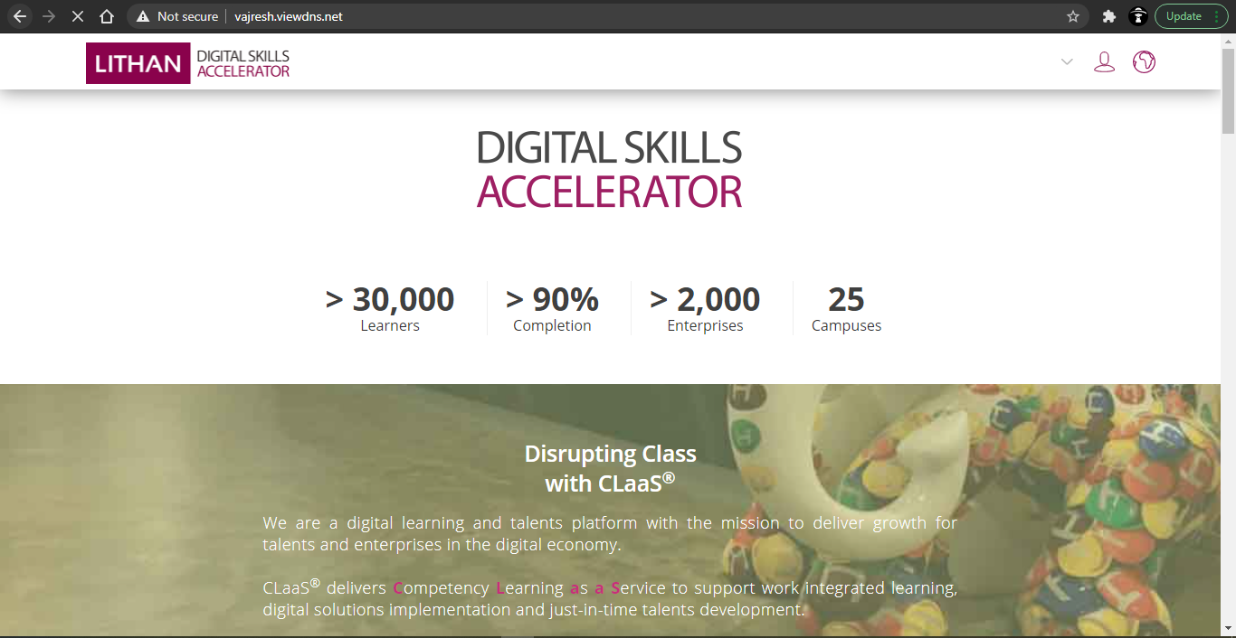

# Protocols

## Intro

* In networking, protocols are set of rules which decides the way machines communicate with each other.
* Some of the common protocols are http, https, ftp, tcp/ip, smtp, pop, etc.

## Why We Use It?

* The machines within a network may use different hardware and software.
* So to set some ground rules when communicating we use protocols to enable them to talk to each other regardless of what hardware and software they use.
* There are different protocols for different processes. Typically protocols are discussed in terms of OSI model layer they belong to.

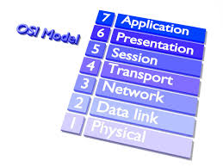

## Common Protocols

* HTTP(Hyper Text Transfer Protocol)
  + It is an application layer protocol.
  + It is designed and used for communication between web browser and web servers to transfer hypermedia documents like HTML.
  + It is send over **TCP**(Transmission Control Protocol).
  + **HTTPS** is **HTTP** with a additional security layer.
* FTP(File Transfer Protocol)
  + It is a standard network protocol used to transfer files between machines.
  + FTP is build on client-server model using separate control and data connections between them.
* IMAP(Internet Message Access Protocol)
  + It is used by email clients to receive email messages from a mail server over TCP/IP connection.
  + Another example for receiving emails is **POP3**(Post Office Protocol), also an application layer standard protocol.
* SMTP(Simple Mail Transfer Protocol)
  + It is communication protocol for email transmission.
  + Mail servers and other message transfer agents use SMTP to send and receive mail messages.
  + SMTP usually use **TCP**
* SSH(Secure SHell)
  + It is cryptographic network protocol for operating network services securely over an unsecured network.

## Port Number

* Port number is communication endpoint which is used to identify the process or type of network service at software level.

|  |  |
| --- | --- |
| **Protocol** | **Port Number** |
| HTTP | 80 |
| HTTPS | 443 |
| FTP | 21 |
| SMTP | 25 (or 26) |
| IMAP | 993 |
| POP3-unencrypted | 110 |
| POP3-encrypted | 995 |
| SSH | 22 |

# Server Hardware

## Intro

* Servers are computer machines with some special software installed and provides functionally for other programs or device over a network.

## Rack Mount



* A rack server also known as rack-mounted server is specifically build to be mounted within a server rack.
* Advantages:
  + High power to run high end applications
  + Convenient
  + Easy Cooling
  + Ideal for Lower Quantity
* Disadvantages:
  + High power consumption
  + High Cost
  + Overheat quickly when stored next to each other
  + Locating Defect can be time consuming

## Tower

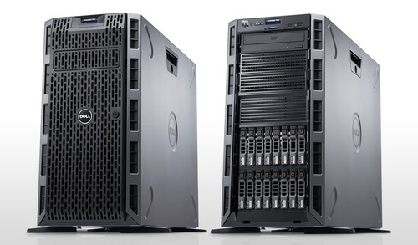

* A server with build in upright cabinet that stands alone. It is similar to a normal house hold personal computer.
* Advantages:
  + Easier Cooling
  + Scalability
* Disadvantages:
  + More Space Consuming
  + Need for more Cables
  + Each Tower Needs Dedicated Fan

## Blade



* A blade server is module server that have multiple servers to be placed in smaller area.
* Advantages:
  + Low Power Consumption
  + Hot Swap
  + Less Need for Cables
  + Higher Processing Power
* Disadvantages:
  + Less Flexibility
  + Less options available
  + More Upfront Cost
  + Size

## Components

* Motherboard
  + The most basic component which connects every other component of server.
  + It accounts for all I/O and a few other important staff.
* CPU(Central Processing Unit)
  + It is also know as processor.
  + This is the brain of the computer.
  + It is one of the factor which is responsible for performance.
* RAM(Random Access Memory)
  + Memory in server don’t refer to hard drive but RAM.
  + It is like short term memory.
  + It is critical for performance of your server.
  + It has currently 4 generations and the latest gen is DDR4(Double Data Rate 4).
* Hard Drives
  + Hard drives offers good performance and reliability but works with parts moving resulting in heat.
  + HDD are replaced with SSD(Solid State Drive) which offers superior read and write speed and don’t move parts when working.

## Types of servers

|  |  |
| --- | --- |
| **Server** | **Description** |
| Print Server | Manage and Distribute printing functionality. |
| File Server | Store and distribute files. |
| Application Server | Run application instead of client for resource intensive applications. |
| DNS Server | Application server that has name and IP address and other details stored. |
| Mail Server | Receive emails send to user and store them until requested by client |
| Web servers | A special kind of application server which hosts program and data requested by user over the internet |
| Database Server | They run database application and respond to numerous clients |
| Proxy Server | Intermediary between server and client. |

## Server Specifications

* Large Servers:
  + Supports up to 7500 concurrent users.
  + 1 TB of disk space for cache
  + 16 CPU cores
  + 64 GB RAM
* Medium Servers:
  + Supports up to 1000 concurrent users.
  + 500 GB of disk space for cache
  + 12 CPU cores
  + 32 GB RAM
* Small Servers:
  + Supports up to 4000 concurrent users.
  + 200 GB of disk space for cache
  + 8 CPU cores
  + 16 GB RAM

# Operating System

## Intro

* Operating system is a software interface between the computer hardware and user.
* Every computer needs at least one OS to run programs.
* Some of the most used OS are listed below.

## Windows server

* It is a brand name for a group of server operating systems released by Microsoft.
* Its default user interface is command line although graphical is available.
* You can deploy either on site or using a cloud computing service.

## Windows OS

* Microsoft windows or windows is group of several non free graphical operating system that is developed and marketed by Microsoft.
* It is a closed source software.
* It is generally used for personal computing.
* It is most used desktop OS world wide.

## Mac OS

* Mac OS X or OS X is series of non free graphical operating system that is developed and marketed by Apple.
* It is primary OS in Apple’s mac computers.
* It is a closed source software.
* It is generally used for personal computing.
* It is second most used desktop OS

## Android

* Its a mobile operating system based on modified version of Linux kernel and other open source software.
* It is designed primarily for touch screen mobile devices.
* It is open source software.

## Linux

* Linux is a family of Unix like operating system based on Linux kernel.
* Linux is generally packaged in a Linux Distribution or Distro.
* A Linux Distribution is OS made from software collection that is based on Linux kernel and a package management system.
* Example of such Distro is Debian, Fedora, Arch Linux, etc.

# Website Designing

## Intro

* Web designing comprises of different skills and disciplines in production and maintenance of a website.
* It includes web graphic design, user interface design, authoring, standardize code, search engine optimization, etc.

## Wire-frames

* Wire-frames are page schematics or screen blueprints that are visual guide which represents skeletal framework of the website.
* It focus on functions available, relative priorities of information and functions, rules for displaying certain information
* Software available in the market are sketch, adobe illustrator, adobe photo-shop, figma, etc.
* I am going to use **balsamiq,** which is online tool as well as available as desktop app. I will use the browser version.

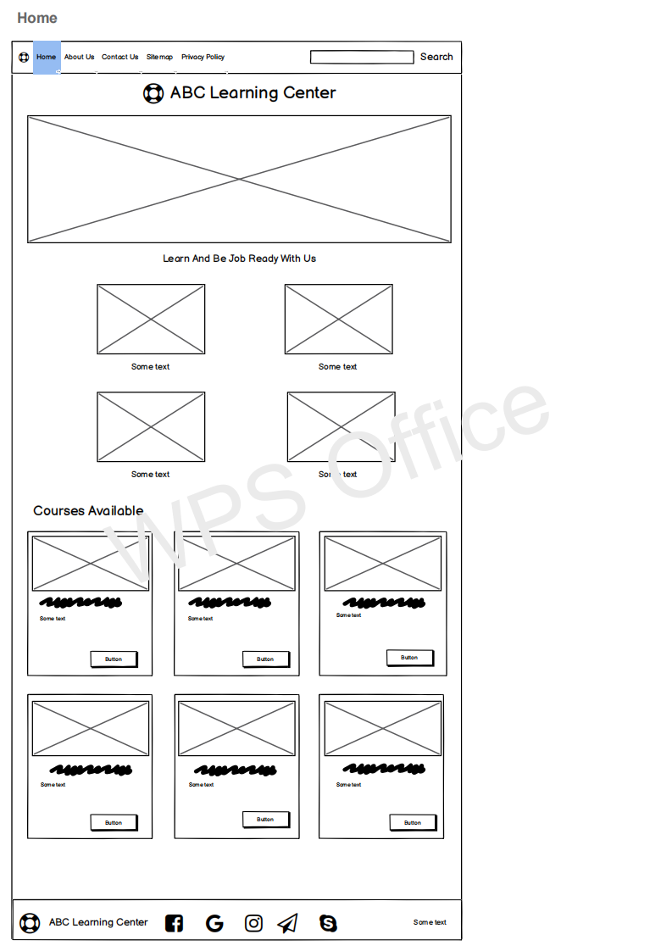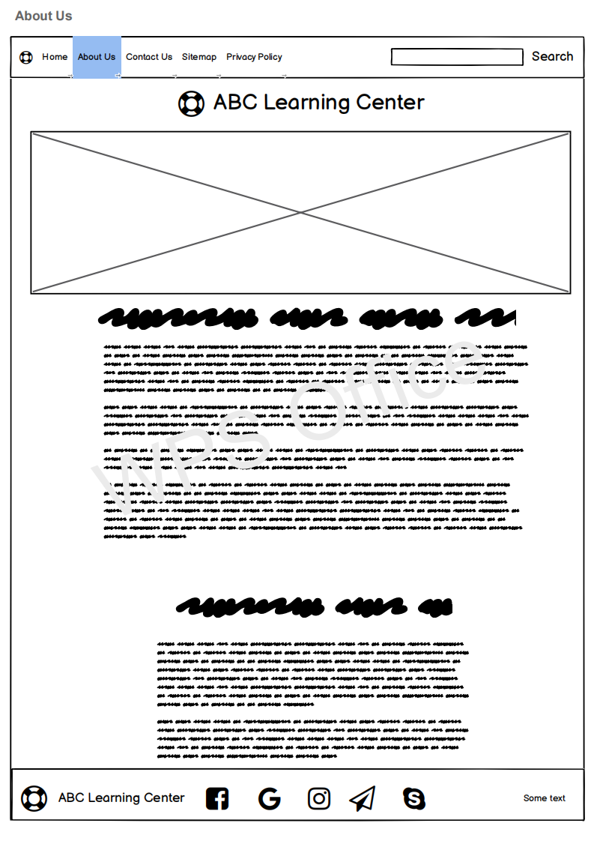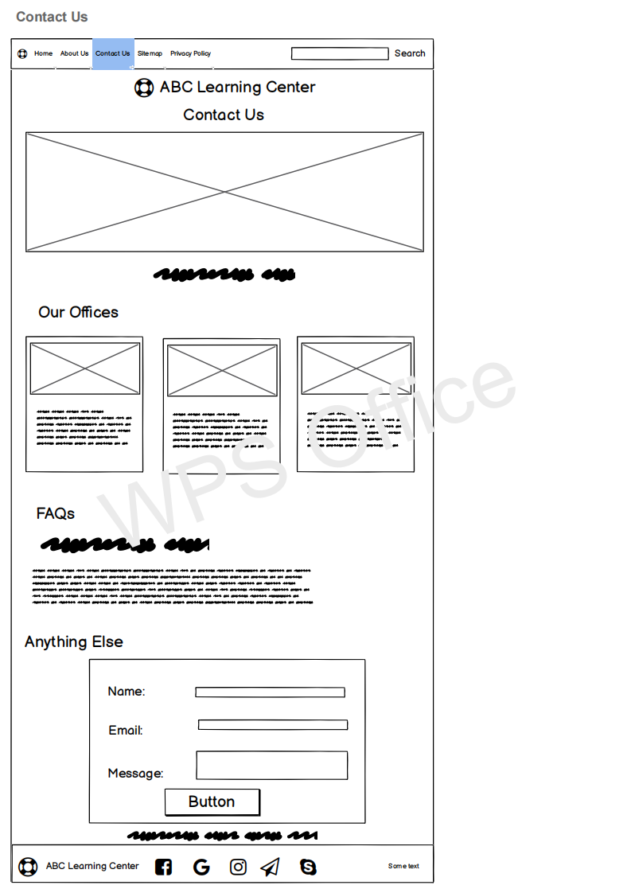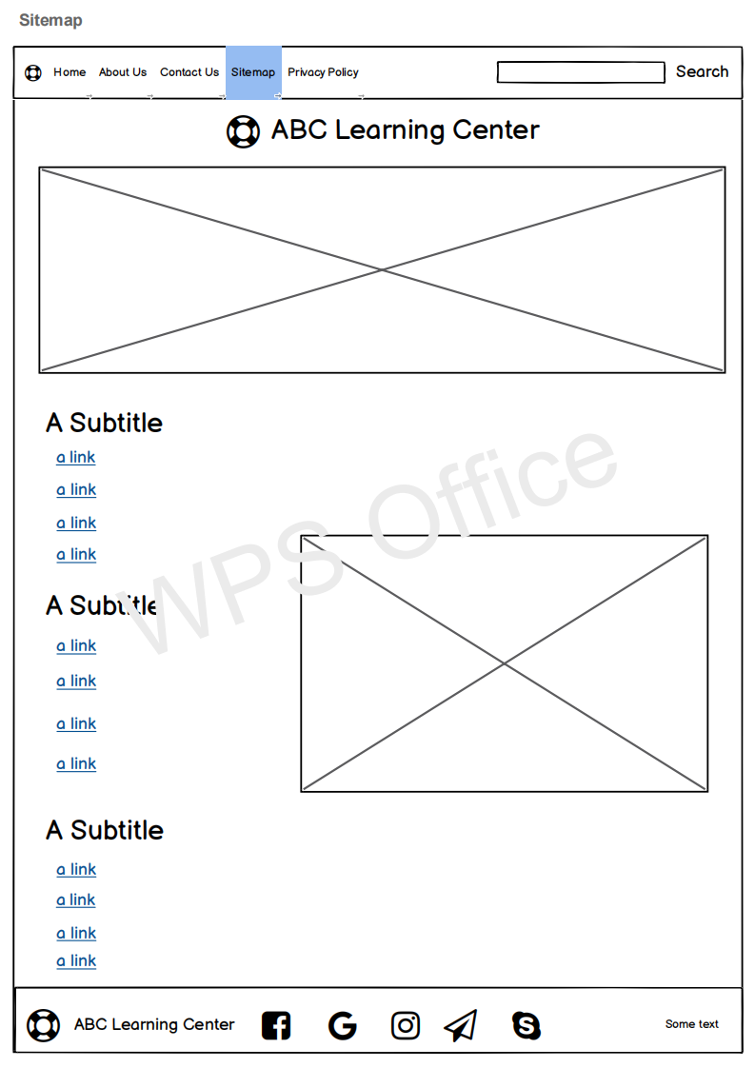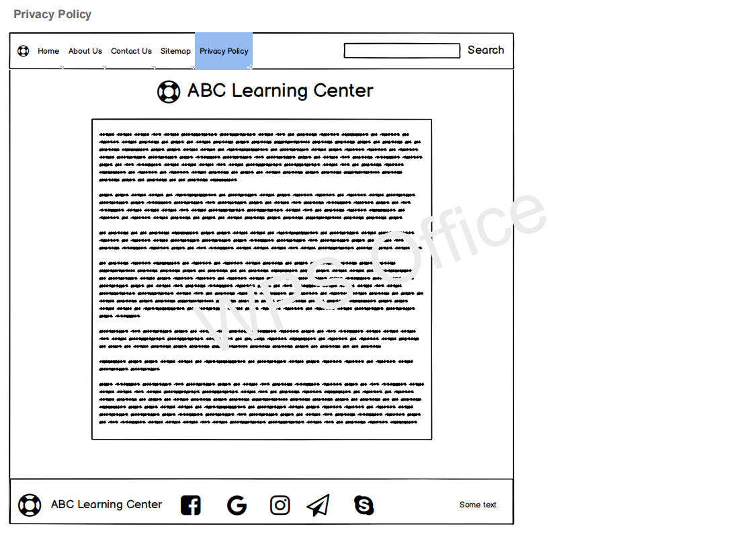

## Information Architecture

* It is the outline of the information in any app or website. It is the structure of your app’s content.
* It has 2 components in IA
  + The site’s content
  + Functionality and structure that defines relationship between site’s content/functionality.
* Even though IA itself isn’t visible in UI but is a foundation of a great user experience.
* That’s why the best time to start creating IA is before the website is even build.
* Some of the tools are DYNO mapper, online whiteboard, OmniGraffle, Smart-Draw, etc.

## Storyboard

* It is the blue print for a website or app. It is simple and flexible.
* It serves as outline of design approach.
* It defines elements that needs to go on each page.
* It shows navigational architecture and information flow and demonstrate how pages work together.
* Adobe After Effects is most commonly used software.

## Website Implementation

* Tools used for website development are **vs code, browsers(chrome), apache web server(or any hosting server).**
* When we need to write code, we need a text or code editor. One of the most popular code editor available in the market is Visual Studio Code.
* It has great plugins and extensions available to be installed. It is light weight and FOSS(Free and Open Source Software).

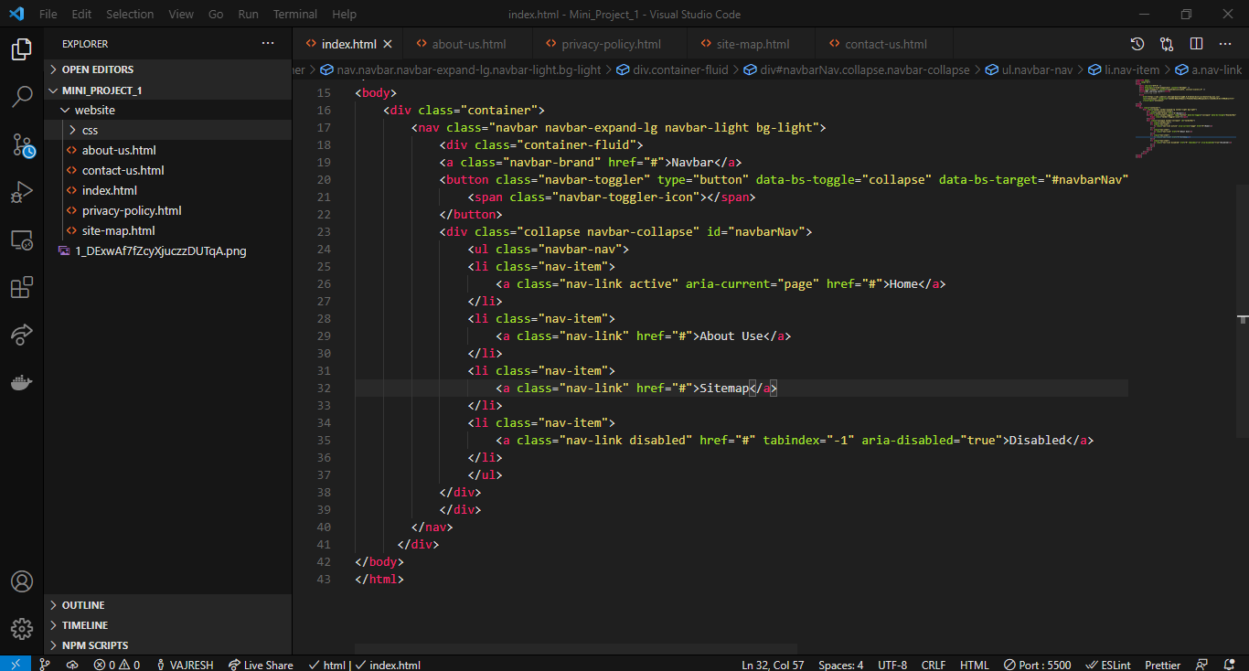

# Web Server Software

## Intro

* Web server software allows computer to act as web server (respond to requests from other computers). Old web servers supported only static files such as HTML and images, but now sites are dynamic and needs server side applications to run process. Nowadays, some web application frameworks include simple HTTP servers. Django framework of python provides `runserver` and PHP has build in server.

## Apache HTTP server

* It is also called as Apache, is a free and open source cross platform web server software released under Apache License 2.0.
* It is developed and maintained by Apache Software Foundation.
* It supports a variety of features. It supports many server side programming languages such as Perl, Python, TCL, PHP. It also has features such as secure sockets layer, transport layer security, proxy module, custom log files, etc.
* Latest version is 2.4 with initial released in 2012 and latest release being in 2020.
* In our project we have to install the Apache HTTP server and configure it to serve our pages.
* Below is the httpd.conf file which is the main file responsible for the server actions. The ServerName tells the servers its domain name and DocumentRoot is the path to the source code.

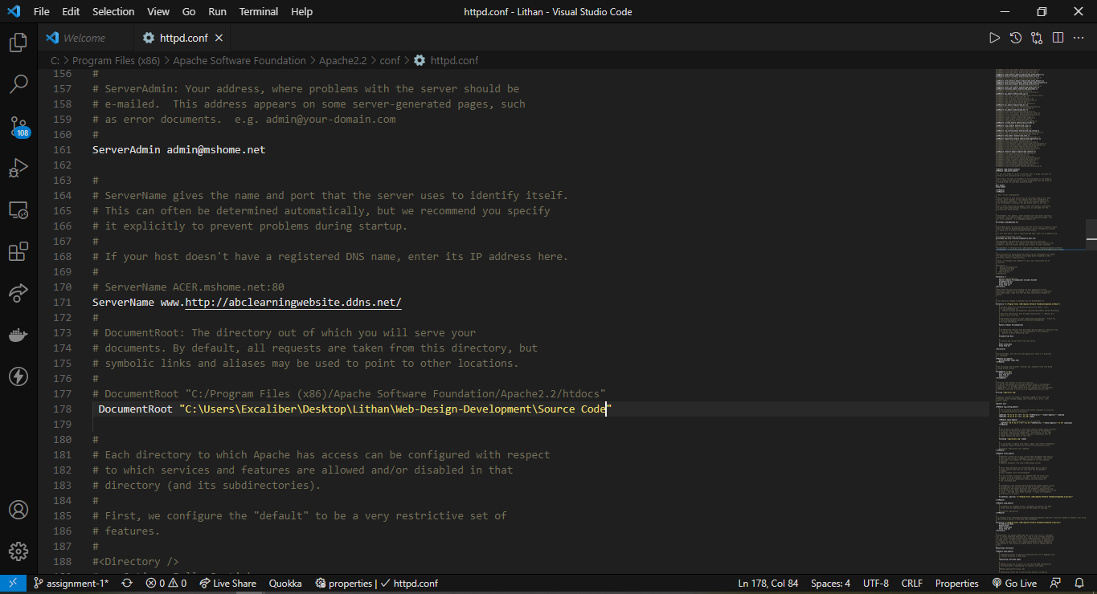

* After starting the server, this is the output.

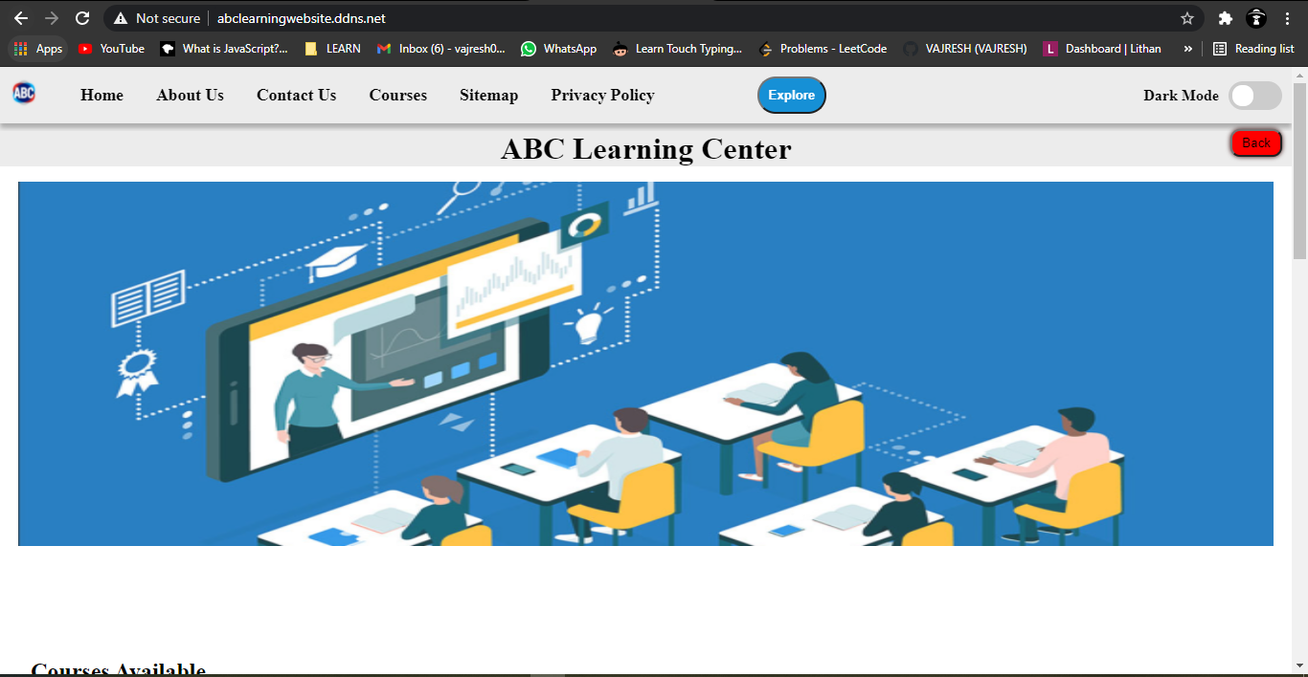

## Apache Tomcat

* It released under the Apache License and latest stable version is 9.0.37 and is maintained by Apache Software Foundation.
* Tomcat is web server which can handle HTTP request and response, and web container which can implement Java Servlets API and is called application server.
* The default port is 8080.
* It is application server designed to execute Java servlets and render web pages that use Java Server page coding.
* It is available as binary as well as its source code version, and it is widely used in various applications and websites across the Internet.

## Nginx

* Nginx is developed by NGINX.Inc. and is has BSD variant License. The latest stable version is 1.18.0.
* It is open source software for web serving, reverse proxying, caching, load balancing, media streaming and more.
* It was designed for maximum performance and stability. Nginx is build to offer low memory usage and high concurrency.
* Nginx excels at serving static content quickly and is designed to pass dynamic requests off to other software that is better suited for those purposes.
* Rather than creating new processes for each web request, Nginx uses an asynchronous, event driven approach where requests are handled in a single thread. One master process can control multiple worker processes.

## Oracle HTTP server

* It is developed by Oracle Corporation and is non free proprietary.
* It is web server based on Apache HTTP server.
* It is web server component for Oracle Fusion Middleware. It provides a listener for Oracle web logic server and framework for hosting static pages, dynamic pages and applications over the web.

# How Website Work?

## Intro

* Websites are made up of two parts, the visual part which is displayed in the browser when you enter a URL is called front-end and the rest is at a remote server which serves the files and save data.
* Both have different technologies associated with them.
* Basic front end technologies are **HTML**, **CSS** and **JavaScript**.
* Basic back end technologies are anyone server side language from **JavaScript**, **Python**, **Perl**, **Go**, **PHP**, etc and a database like **MySQL**, **SQL sever**, **MongoDB**, etc.

## Front-end

* This is the code which is rendered and displayed in the browser.
* **HTML**
  + It stands for **H**yper **T**ext **M**arkup **L**anguage
  + This is a markup language which defines the structure of the page.
  + It is written and parsed based on the tags you define in the code.
  + The latest version is HTML5 which have many features provided with the help of the browser.
* **CSS**
  + It is a stands for **C**ascading **S**tyle **S**heet.
  + It defines the style and design of the website.
  + It details with how the content is placed, what is background of the page or the elements, typography of the page and other design elements.
  + It has to be linked to the **HTML** file for working.
  + There are many frameworks and libraries that helps in creating great design with minimal **CSS**. **Bootstrap**, **Material UI**, **Tailwind CSS**, **SCSS**, **SASS** are some of the examples.
* **JavaScript**
  + **JavaScript** is the scripting language which helps to make the page more dynamic and interactive.
  + **JavaScript** also helps in data fetching from remote server over a network.
  + Many **JavaScript** frameworks and libraries are there which are makes the front end development more comfortable.
  + **JQuery** is a **JavaScript** library which is small, fast and feature rich library. It makes DOM manipulation, event handling, animation, AJAX, etc simpler and easy to use.
  + These frameworks and libraries also enable us to write **HTML** and **CSS** in **JavaScript** which will generate separate files after compilation on the fly. **React**, **Angular**, **jQuery**, **Svelte**, etc are some examples.
* JavaScript is used in validation of the form and then redirecting the user to another page after successful registration.
* Here are the screen shots of output of the validation done by JavaScript. The code is not attached here, but you can look it in the validation.js file in the source code.
* This is how the form looks when user visits for the first time

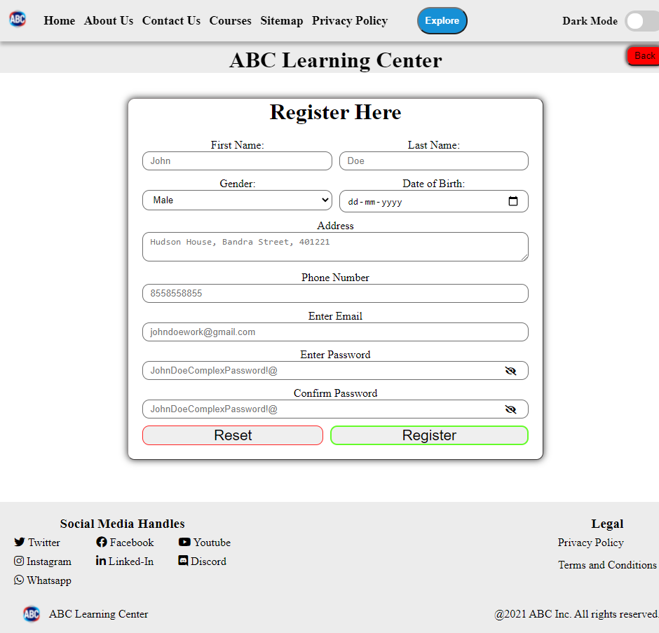

* If the user tries to register without any data enter, this is the output

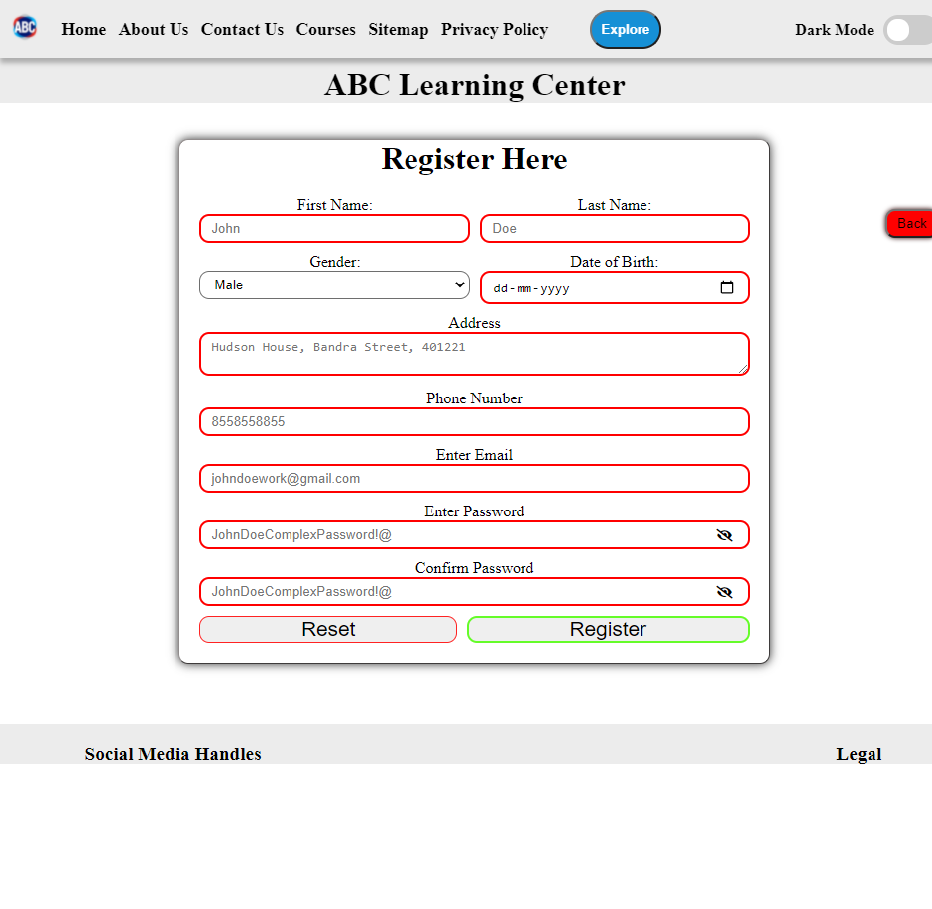

* User entering invalid email address.

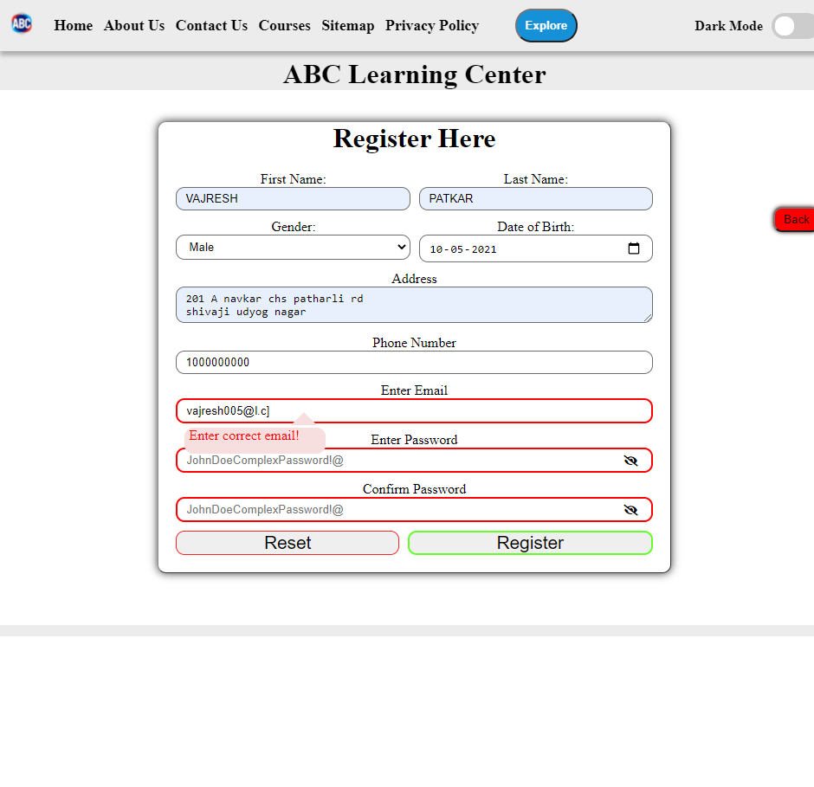

* If the user left some fields unanswered, user is warned.

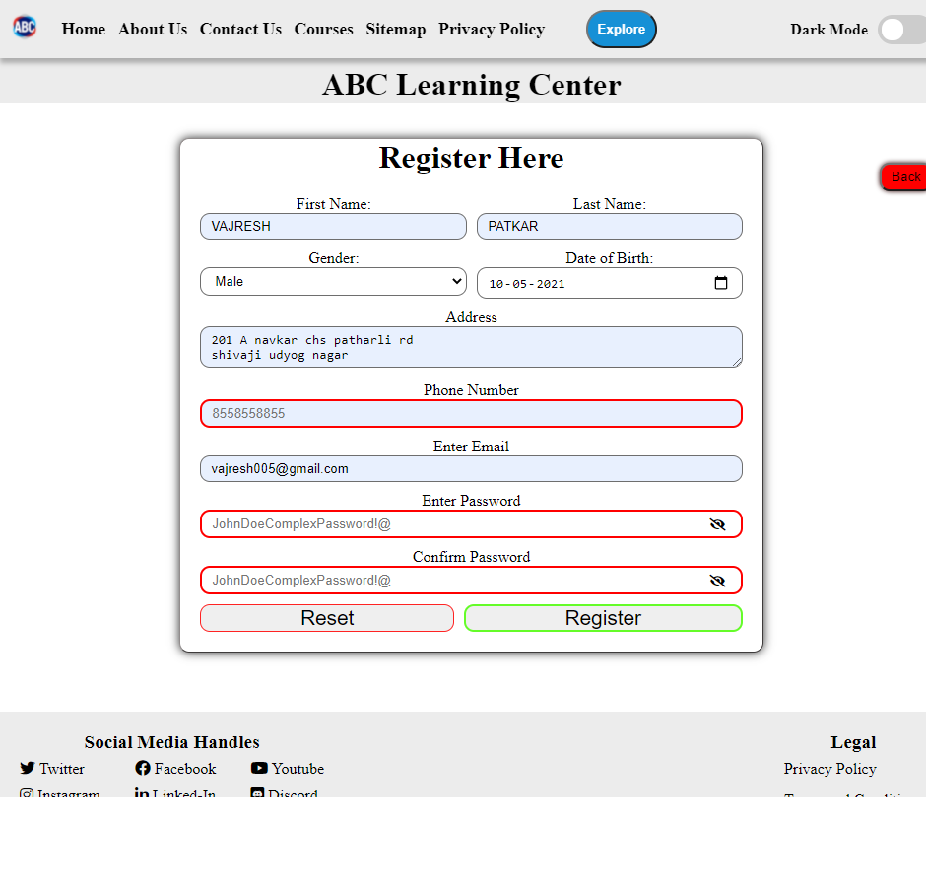

* The strength of password is measured and pop up are given accordingly.

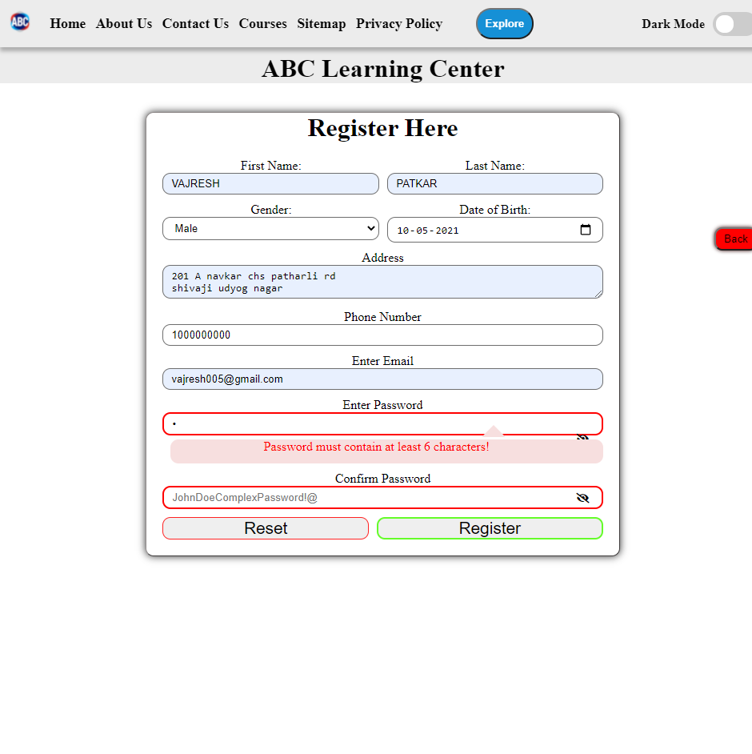

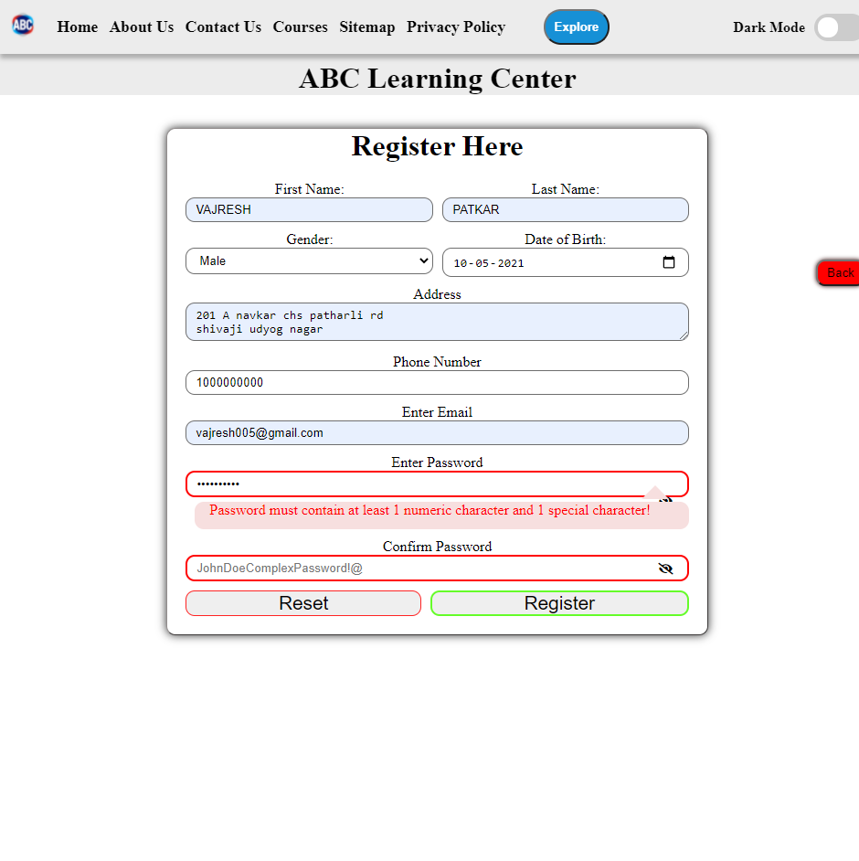

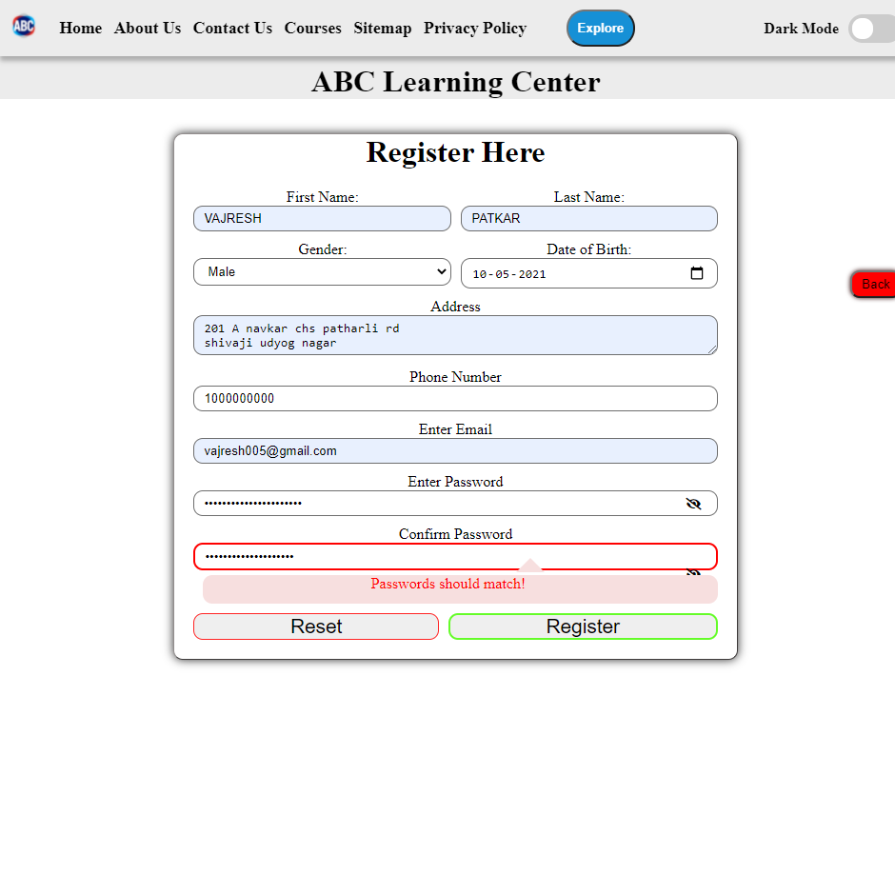

* After user has successfully enter all the data correctly, he is redirected to thank you page.

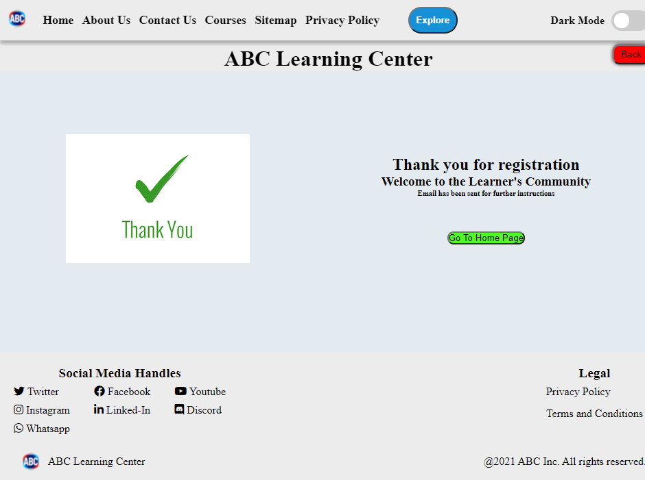

## Back-end

* This is where the logic is written for how to provide the website files after a request is made. It enables websites to process actions that users take on front end and deliver correct response for it.
* **Java** 
  + It is one of the popular programming language that can be used to develop apps in Andriod, GUI based programs, website development, database connectivity, image processing and many other.
  + Same **Java code** can be executed on different platforms due to JVM(Java Virtual Machine).
  + **Java** frameworks for back end development are **Spring, Grails, Struts, Java Server Faces(JSF), Hibernate, Drop wizard,** etc
* **JavaScript** 
  + Currently **JavaScript** is one of the most popular languages for writing back end logic.
  + **Node JS** is a runtime environment and **express** is a **JavaScript** framework which helps in back end development.
  + Static site generators, Jamstack, server-side-rendered pages are some of the modern methods to develop website. They include development of front end form site generators and connecting them to headless CMS.
* **Python**
  + It is another language which is loved by many developers. **Flask** framework is for small website and **Django** is a framework useful in creation large websites.
* **PHP**
  + It was one of the first server side language used to develop dynamic pages.
  + You can collect form data, manage cookies with **PHP**.
  + Dynamic page content and server side script can be done with **PHP**.
  + **PHP** can also be used for command line scripting and to create desktop applications.
  + Popular PHP frameworks are **Laravel, Symfony, CakePHP,** etc.
* **.NET Framework**
  + Web applications can be build using languages like **Visual Basics(VB)**, **C#, F#**, etc.
  + **C#** is popular among developers as it has the power of **C++**(another low level language) but it is easier to work with.
  + **VB** is a programming language that uses a graphical user interface to modify code written in BASIC programming language.
* **Database**
  + Back end logic is not enough to store data, so to store data we need databases.
  + Databases are nothing but excel sheets with much more functionality for store and retrieving data.
  + These databases are manged by database management system.
  + **SQL** is one of the popular language used for communication with database.

## Comparison

|  |  |
| --- | --- |
| **Front End** | **Back End** |
| It written in **HTML**, **CSS** and **JavaScript** | It can be written in **Python**, **JavaScript**, **Java**, **C#**, **Scala**, **Go**, etc. |
| It is rendered and displayed in the browser | It is executed on a server machine. |
| The front end files are received by the browser. | They send the front end files to the browser when requested. |
| Front end developer mostly deals with the design, UI, UX, SEO, etc. | Back end developer deals with core logic of how to make the process clean and optimized for best performance, memory management, etc. |
| End Users interact with the front end. | End Users don’t directly interact with the back end. |
| Generally uses API for displaying data from database. | Creates and provides the API to front end developers. |

## Website Working at Layers Level

* For communication over a network computers use the **OSI(Open Systems Interconnection) model.**
* It has seven layers.
* The modern Internet is not based on **OSI** model but on a simpler **TCP/IP** model. However OSI model is still widely used as it helps in visualize and communicate how network operates and helps to isolate and troubleshoot networking problems.



* **Application layer** is used by end users software such as web browsers and email clients. It provides protocols which allows the software to send and receive information and present meaningful data to the users.
* Protocols provides by the application layer are **HTTP(S), FTP, SMTP, POP, DNS.**
* **Presentation Layer** prepares data for application layer.
* It defines how two devices should encode, encrypt and compress the data so it is received correctly on the other end.
* The presentation layer takes any data transmitted by application layer and prepares it for transmission over the session layer.
* When we enter a URL in the browser, the application is the browser. The browser selects which web server it is sending data to, contacts the server and send the request.
* When a response is returned, the browser displays the desired content on the web page.
* Usually the data send from the server is in different format such as **HTML, CSS, JS,** images, etc., so in the presentation layer these files are converted into **XML** format to be displayed on the browser by **Abstract Syntax Notation One.(ASN.1).**

# **Tools for building Website**

## Intro

* You can create a website with HTML, CSS and JavaScript. You have to code from scratch.
* There are website generators like **word-press, wix, drupal** which helps you in creating website with drag and drop.

## Website Generators

* Word-press is a free and open source content management system written in PHP and connected with a MySQL or MariaDB database. Features include a plugin architecture and template system called as Word-press Themes.
* To create a website with word press you have to create a new account on [www.wordpress.com](http://www.wordpress.com) and click on Log In in top right corner.

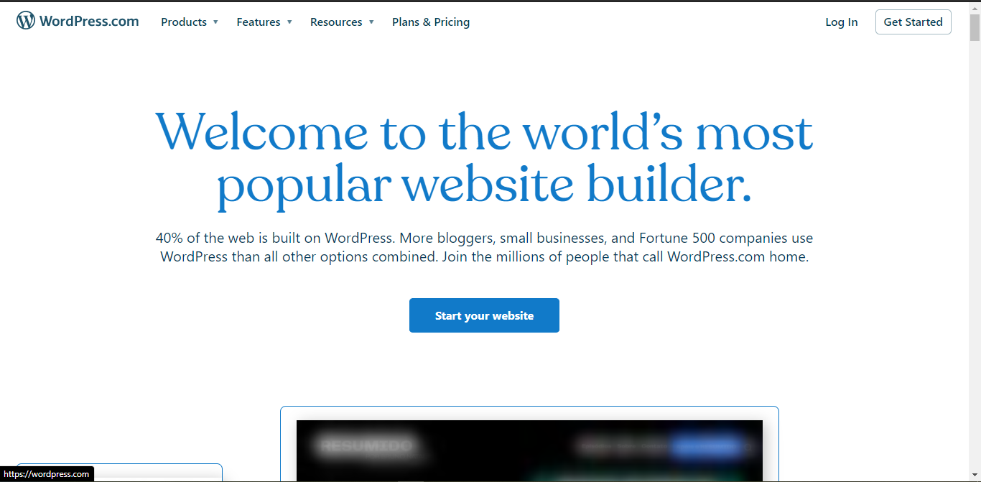

* Enter account details if you previously signed in or click on create new account.

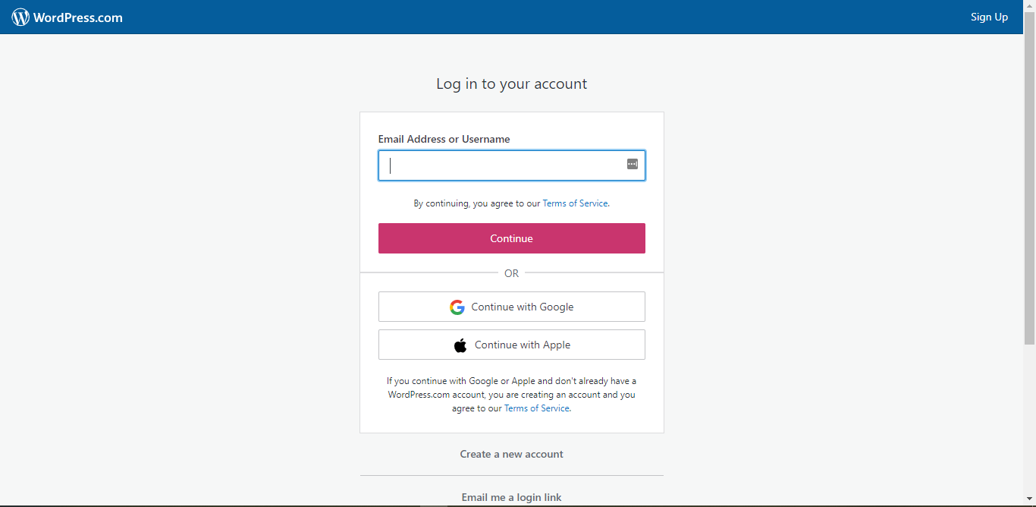

* Enter details to sign in or go with social sign.

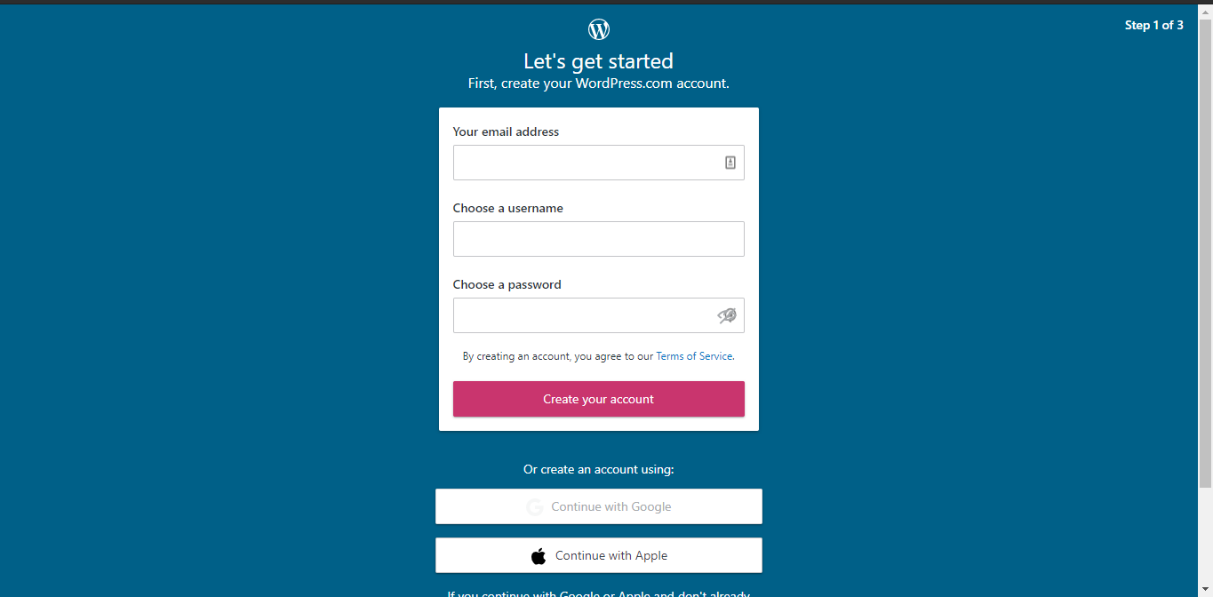

* Enter a domain name you want, select available domain name from below.

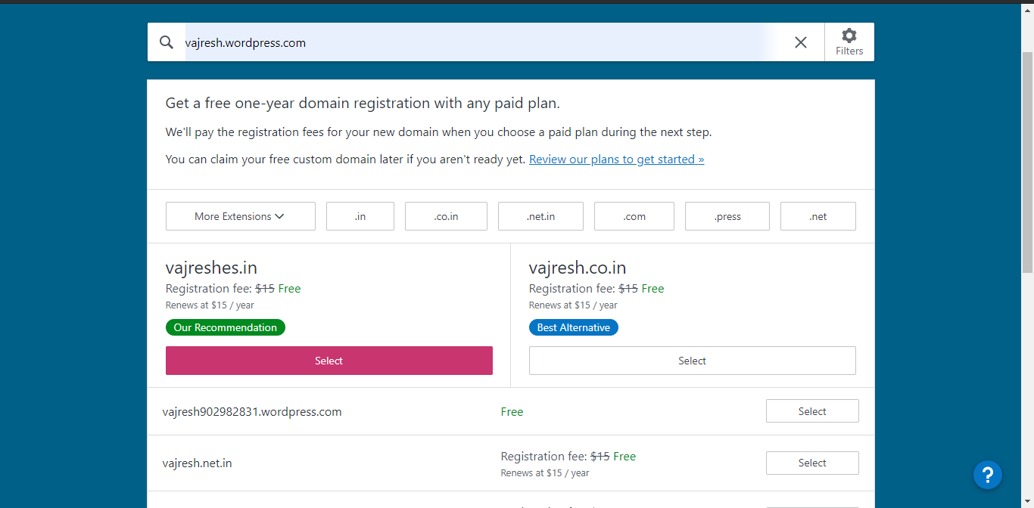

* Choose anyone plan or if you want to try for free click on start with a free site option.

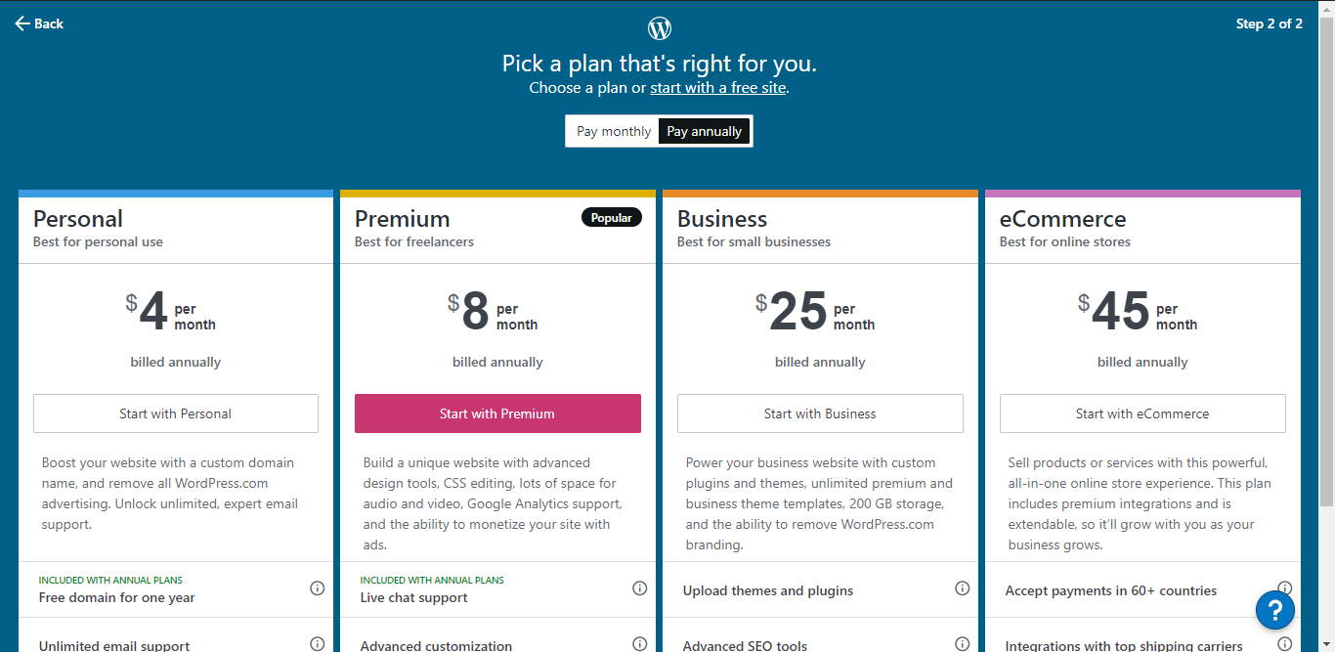

* And now you can see the website page

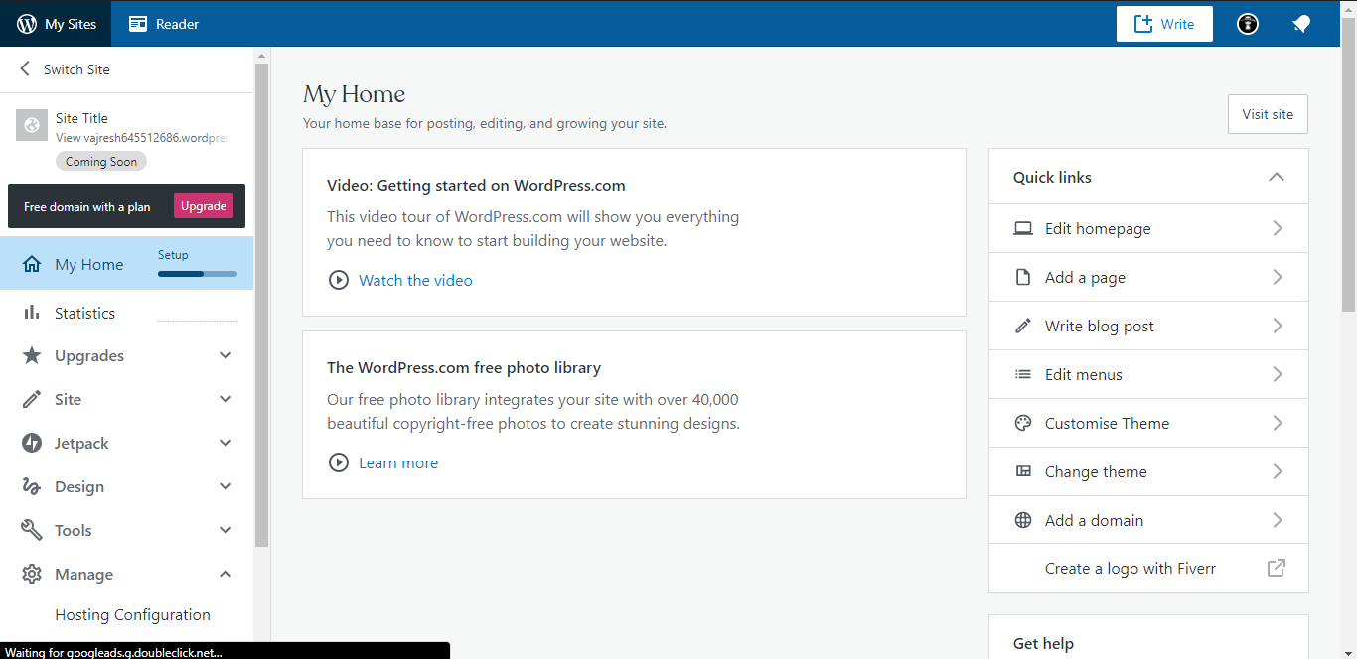

* Add changes to you word press site.
* I tried to recreate ABC learning center website. I am not satisfied with the results as it only allows certain elements to change.

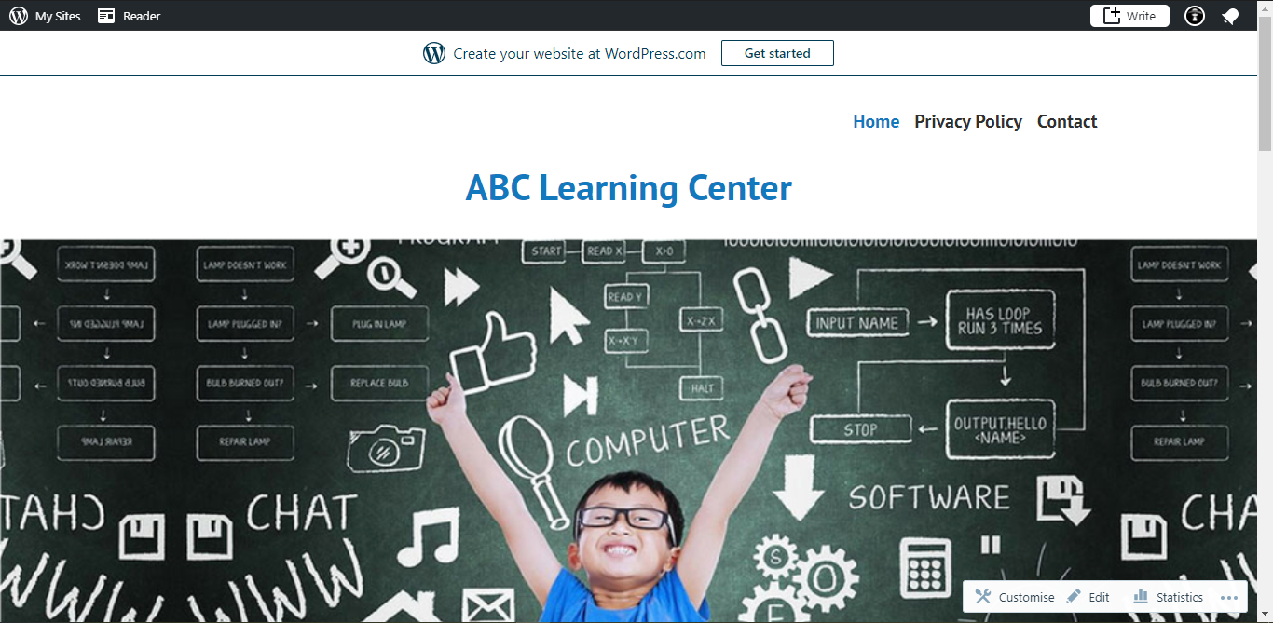

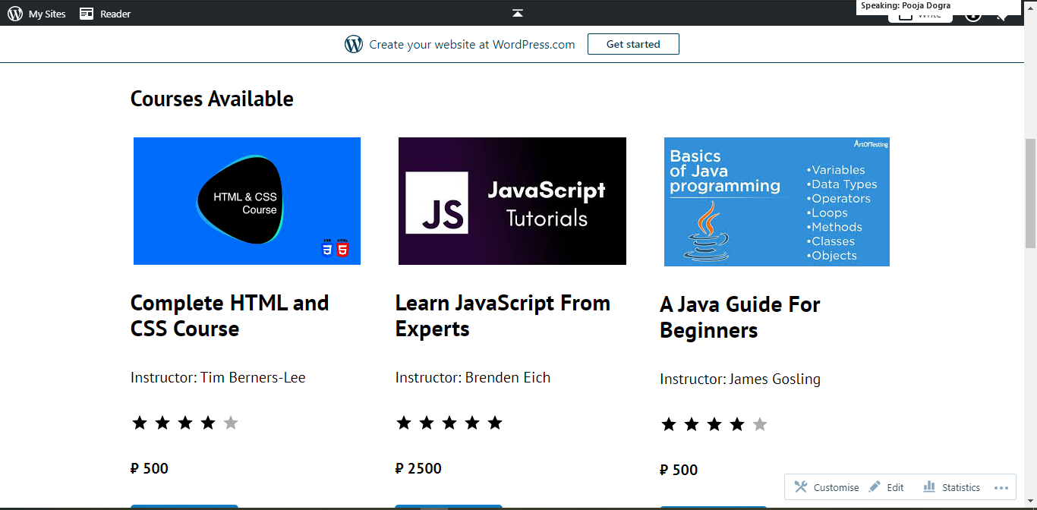

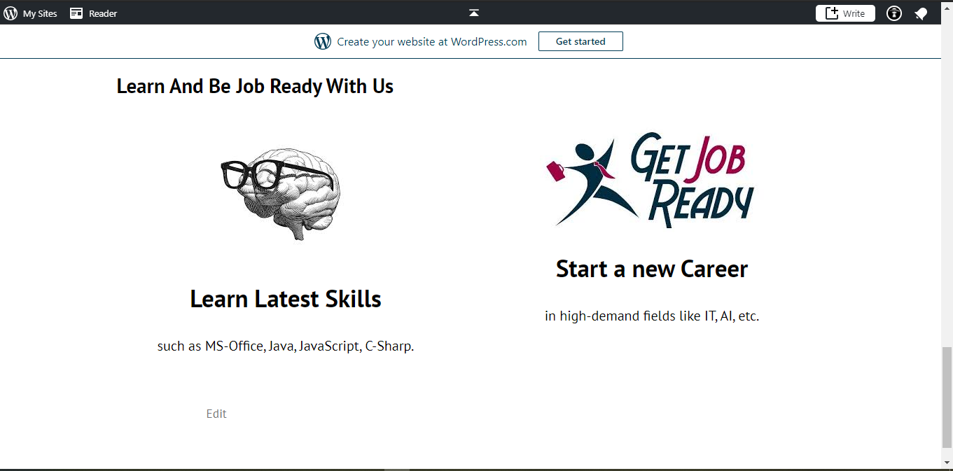

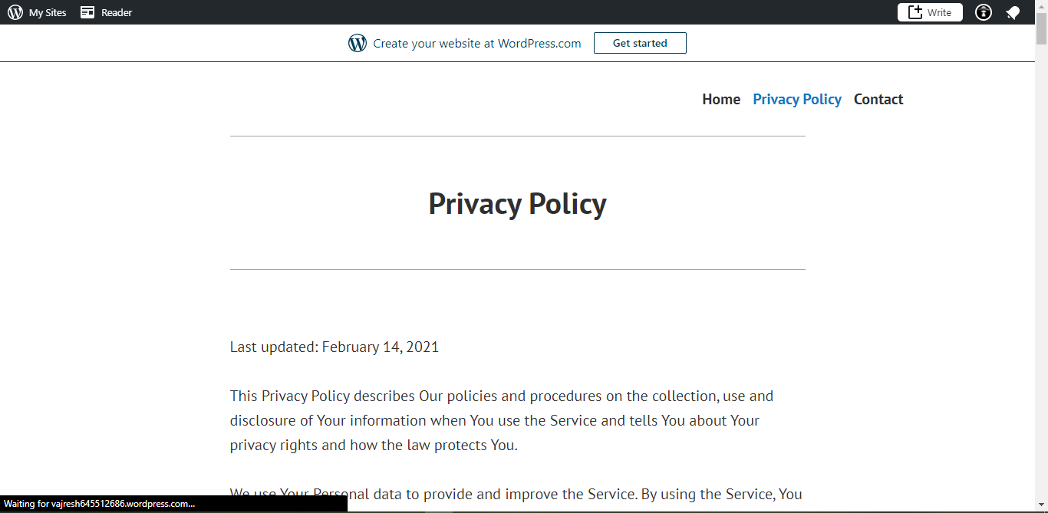

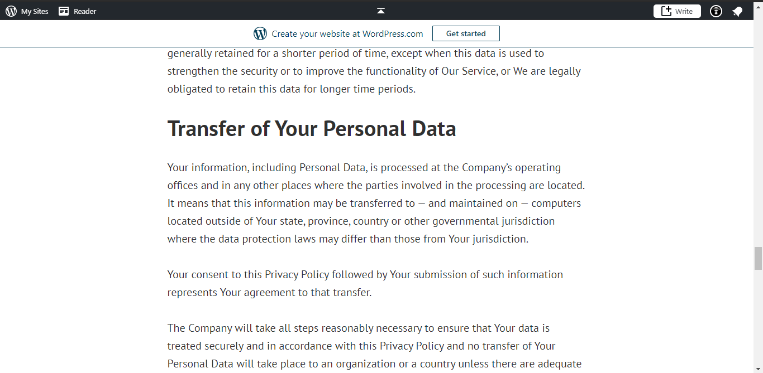

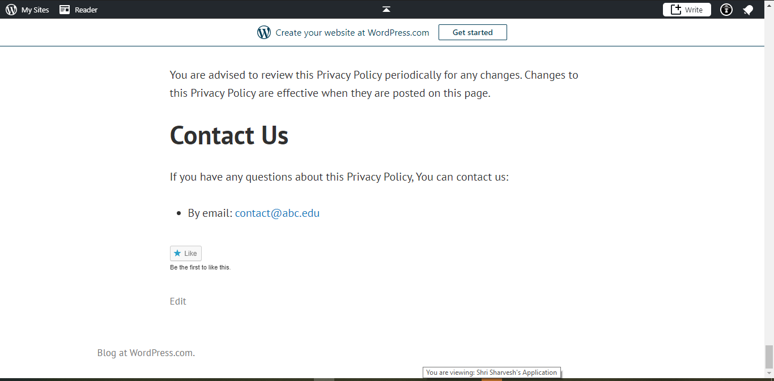

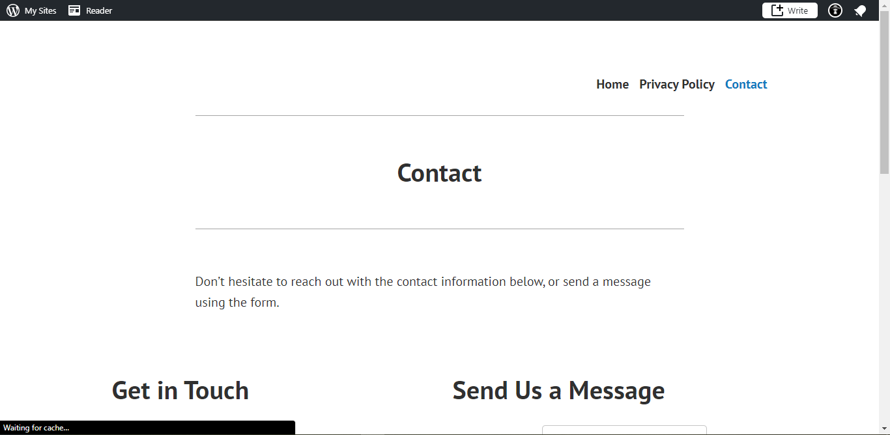

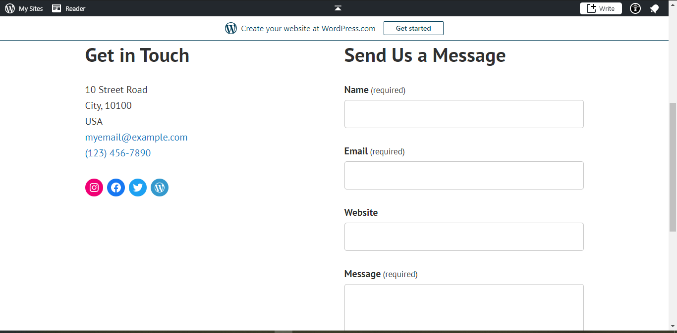

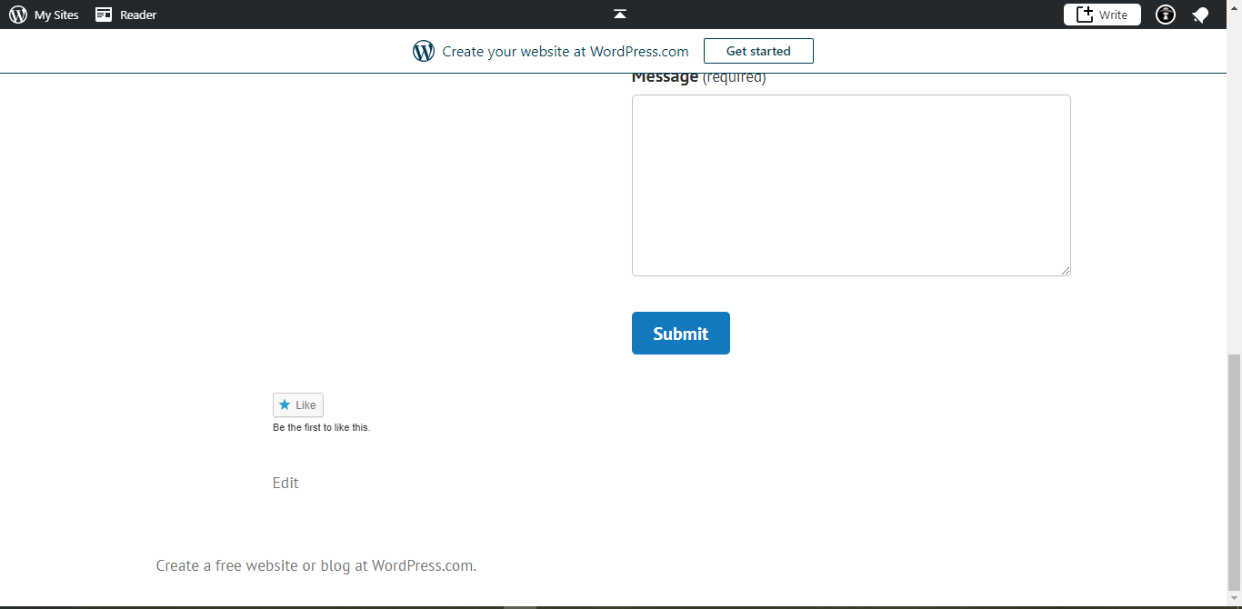

## Custom Building From scratch

* Building a website from scratch can be lengthy process if you don’t know how to write HTML CSS and JavaScript.
* It gives you full control over your website and you can edit it however you see fit.
* For creating a website you need to write HTML and CSS in a code editor. There are many code editors available for free such as brackets, dream weaver, notepad++, vs code, sublime text 3, etc.
* I recommend using vs code for writing HTML and CSS as it is free of cost and open source software. It has many extensions which saves your time while writing code and makes the code visually appealing.
* VS code also has default extension emmet which helps you to write HTML faster which few words. It also auto-completes sentences based on context.
* VS code offer many keyboard shortcuts out of the box and also allows you to edit or create new shortcuts as you see fit.
* Here is an example of how VS code makes the code looks clean and beatify the code.

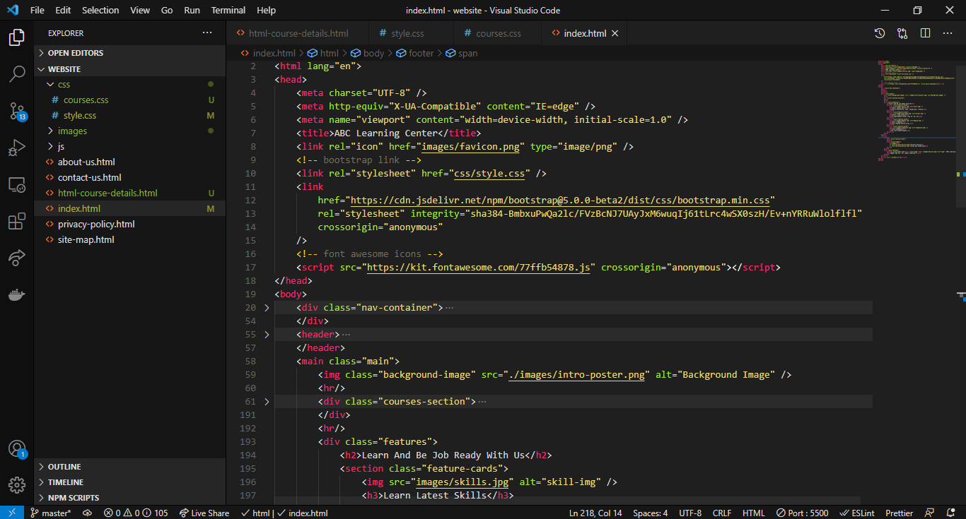

* This is the ABC Learning Center website homepage created using HTML and CSS.

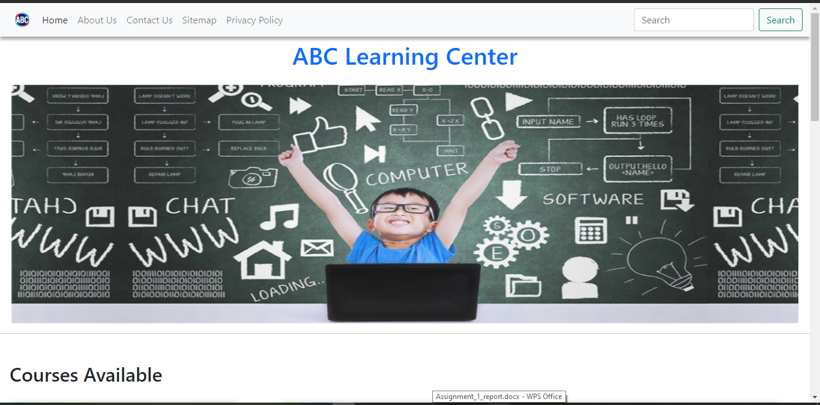

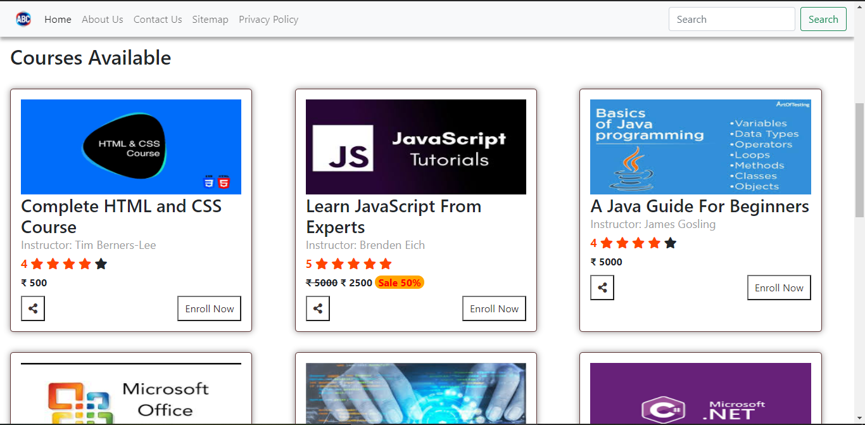

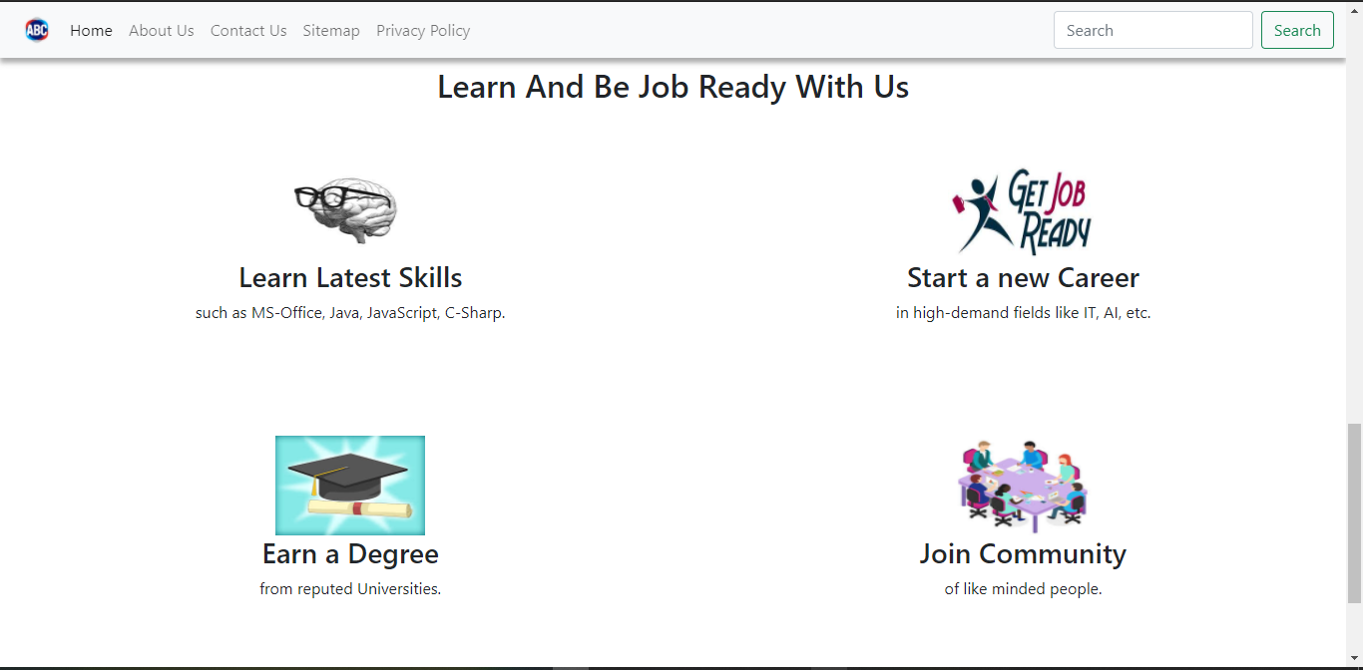

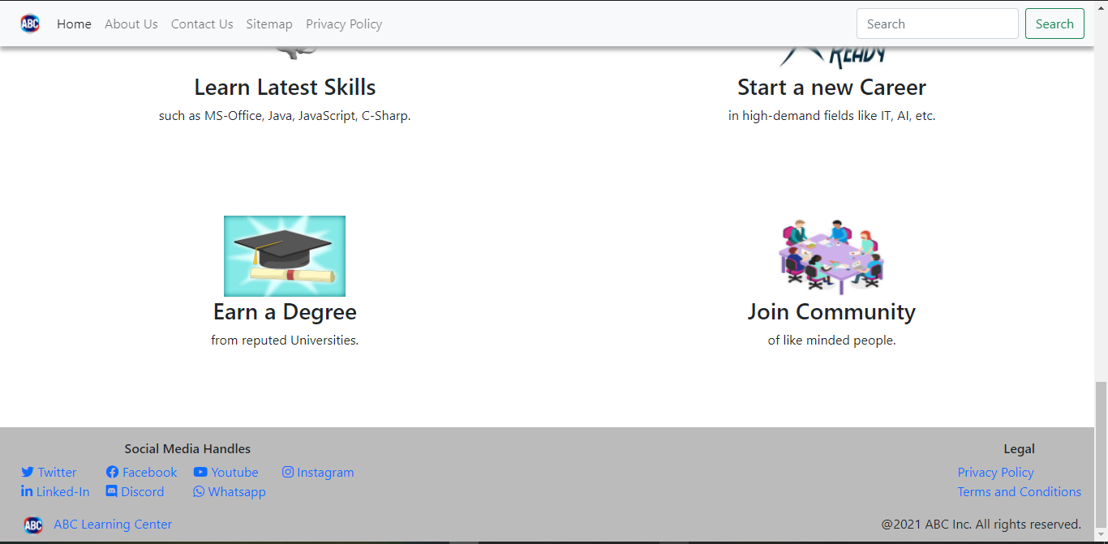

## Comparison

|  |  |  |  |
| --- | --- | --- | --- |
| **Sr. No.** | **Parameters** | **Website Builders** | **Custom Build** |
| 1 | Performance | The speed is less as it consumes more server resources and you can’t modify the code for performance. | The speed is high as it uses limited resources and you can modify your source code for better performance. |
| 2 | Functionality | The functionality is limited and only extend till what is provided by the builder. | Functionality is unlimited but requires you to have knowledge of how to write the code to acquire that functionality. |
| 3 | Flexibility | Not much flexibility is provided and can be personalized only to a certain extend. | Full control is being accessed. You can create fully unique website that fulfills your needs. |
| 4 | UI | Basic templates are provided and you can tweak a little. | You need to plan and create a design template for you website and then code it yourself. |
| 5 | UX | Limited templates are available and using them may result in similar looking website available out there. | Custom websites are designed keeping in mind your objectives , goals which results in unique experience for user. |
| 6 | Cost | This can be cost effective. Word-press themes are available within the price range of $0 to $80. | This can be costly as you may have to pay the designer as well as the developer. Web development cost 90% of the total from development to hosting. |

# Changes over the years

## History of Web

* In 1991, the world wide web came into existent. The first website, CERN, went live in November 1992. It was 100% text based and only had default blue color of hyper text.
* In early days website design, <table> tag of HTML was used to provide structure to the page. There were some benefits for using <table> but it was very difficult to maintain and reuse. Although tables have paved the way for grids of the future.
* In 1993, ALIWEB(Archie Like Indexing for the WEB), the first search engine, was launched. They wanted users to be drawn to sites links. They used colors to drew users attention to more important elements of the page.
* Another huge change in the same year was birth of landing page. MTV was early adopter of landing pages and this was the image you saw when you landed on their site in 1993. The internet was growing rapidly and so was design, interactivity and functionalities.
* JavaScript came into existent and helped designers to overcome limitations of static HTML by allowing them to bring some motion to web. The problem was it took longer to load. Many of early functions of JavaScript were later accomplished by CSS.
* CNN’s 1996 year in review is iconic web page with balanced web design using text, images, ads.
* Flash was introduced and changed the website design. For the first time, designers were able to create any shape, add animation and develop more engaging sites using a single tool. But the main issue was that not every user had a Flash plugin. The lack of being search friendly and its heavy consumption of processing power caused Apple to leave it behind in 2007 release of iPhone.
* Google beta went live in September 1998. Instead of opting for a link filled page, Google choose minimalistic route and it worked well for them.
* Shortly after creation of Flash, CSS made its way into the scene. The only problem was browser support which CSS fought through and still is one of the most important language a web designer should know.
* Until 2000, website design was much more of technical field handled by company IT departments. In 2003 that changed, Word press, which is now the leading CMS(Content Management System) was launched.
* MySpace became a place for users to create their own profiles and connect with other online users. They allowed their users access to HTML editors in order to customize their profiles.
* Facebook was launched in 2004 but it was reserved only for college students and you had to have a .EDU email address to get access. In 2006 this changed and Facebook went public. Facebook didn’t allowed user to customize their profiles which lead to a simple, consistent look throughout the network.
* Mobile devices and smart phones changed how we looked and thought of web. In 2007 most sites were not mobile friendly by any standard and using web on mobile was frustrating. This forced designers to create a better approach towards mobile web design.
* In 2007 iPhone was released and they also introduced App Store in 2008 which allowed third party users to sell their products.
* In 2010, Backbone JS was introduced which attracted many developers. Developers started to focus on optimized the apps, security and ease of usability.

## Responsive Design

* After introduction iPhone, the usage of mobile was wide spread and people wanted mobile sites but there are a lot of ways to do that and Responsive Web Development is something that designers prefer. Designers notice in action and they like to implement it.
* The rise of mobile has transformed many aspect of web development and changed user expectations. It forced the developers to create web applications that behave more like native application.
* Due to this, there is a shift towards client side development.
* Previously we had client-server architecture. But due to client high demands and evolving of JavaScript client side development is increased.
* LAMP stack is being replaced by MERN, MEVN stack due to JavaScript.

## Single Page Applications

* In the past a web application or a website consisted of multiple pages all linked together.
* The problem with this approach was that the pages load slower on mobile devices.
* Navigating a complex site becomes frustrating on a mobile device, as the user must wait around for pages to load.
* As a result, we’re seeing applications switch to a single-page approach which make the website seems faster.
* Again, JavaScript and AJAX are one of the factors that influence this change.

# Search Engine Optimization(SEO)

## Intro

Search Engine Optimization is the process of improving your site to increase its visibility for relevant searches. It increases the chances of your website to be at the top of the search.

## How does SEO works?

Search engines like Google, Bing uses web scrappers and bots to crawl pages on the web, collects relevant information and index it. Next algorithm analyse pages in the index and determines which the order of pages should appear in search result for a given query.

Search algorithms are designed to surface relevant, authoritative pages and provide users with an efficient search experience. Optimizing your site with this factors can rank your website at the top of the search results.

## Factors that affect the ranking and how to improve it.

Google updates its algorithm very frequently. This means that what works now may not work tomorrow, so you have to constantly improve and update content.

* **Good content**

Having good and reliable content is the most important part of your website. This not only helps the users but also helps you to rank up.

* **Page load time**

Google’s algorithm effectively rewards speed in the back-end as compared with front end. Although this does not have a direct impact on ranking but slow loading web pages can decrease user experience resulting in higher bounce rates( user leaving web pages ) which affect negatively on your ranking.

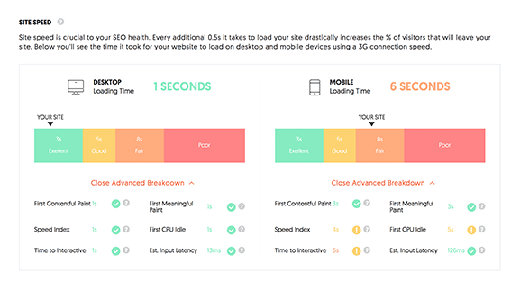

* **Keywords**

Using relevant keywords can help the search algorithm to identify what your site is about and what is provides results in top in search results for related keywords.

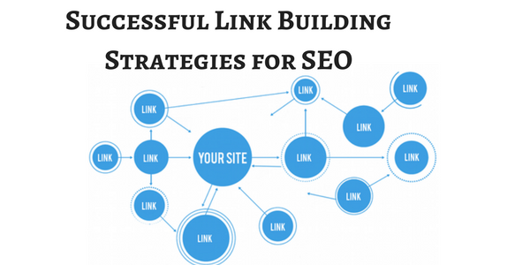

* **Site map and Links**

Relevant links in your site will have a positive affect and helps search engine to determine that your site is filled with relevant content. Using too many links could indicate a site to be spammy and not useful.

* **HTML tags**

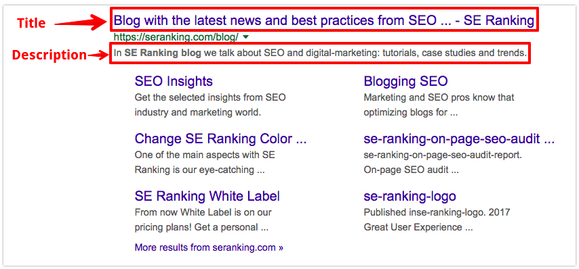

Title tag provides a quick overview of the page. It is also displayed along your website in the search result. Having a good and short title can increase the traffic to your website.

Meta tag plays very crucial part in ranking your site. This is the tag helps the search engine knows about your website and its content. The description must not exceed 150 characters.

# Tools for custom website development

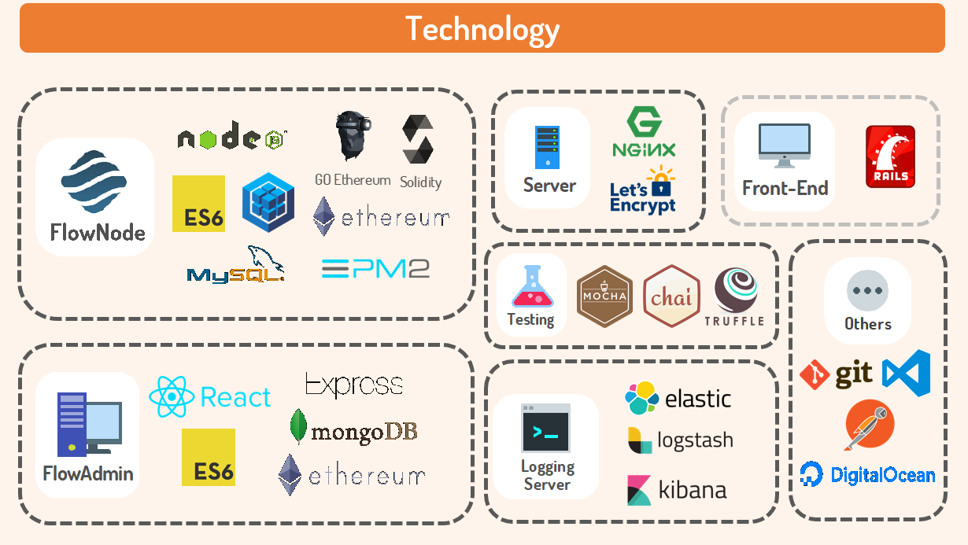

## Intro

* For custom website development you need to have knowledge of HTML, CSS, JavaScript, knowledge of IDE or any code editor, hosting servers or software, and version control.
* With this knowledge you develop a front end interface.

## Available Tools

* For designing and mock-ups of the websites we have many tools such as **Balsamiq, Adobe Illustrator, Photoshop, Design XD, Figma, Sketch,** and many other.
* **HTML, CSS** are must to create any website. Any framework or libraries you use are converted to plain HTML and CSS at the end as browsers are designed to parse only HTML.
* There are many libraries and frameworks that makes a developers life easy.
* Simple once are **bootstrap**, **tailwind CSS**,etc There are CSS pre-processor and post-processor such as **LESS**, **SCSS**, **SASS**, etc which generates optimal CSS.
* JavaScript has simple library which abstracts complex functionality and makes a developer’s life simple. **JQuery, Anime Js,** etc are some the examples of simple libraries.
* JavaScript libraries which takes development to a whole another level are **React JS**  and its ecosystem with a tons of tools and libraries for design, development, state management etc are also widely used.
* **Next JS** is a framework created to overcome some of the **React JS** drawbacks.
* There are also static site generators which takes JavaScript as input and build static HTML pages which can be send to the client. This types of site are very secured due to its static nature.
* To run JavaScript outside the browser **Node JS** is used to provide a runtime environment. It is based on the V8 engine of the chrome.
* **Angular, Ember, Backbone**, **Svelte** are JavaScript front end frameworks, **Express, Koa, Nest** are JavaScript back end frameworks.
* Since JavaScript is a dynamically typed language, it is prone to errors and bugs. To make the JavaScript a statically typed language **TypeScript** is used.
* Transpiler like **babel** is also available which converts latest version of JavaScript code to some previous version which is supported by all browsers.
* To increase the speed of the website, all the files needs to be compressed into a minified version so that it takes less space. To minify all the front end assets, **webpack** is available.
* There are other libraries and frameworks of JavaScript available for making native apps. **Electron** is JS framework used to make native desktop app. **React Native, Iconic** are some of the popular libraries used to make cross platform native mobile apps from a single code base.
* So basically **JavaScript** started off within the browser is now available at every front in software development.

## Tools I Used

* I used **Balsamiq** for designing the wire frames because I was familiar with its environment and to use it I don’t need to download anything since it runs inside browser. Also it have many tools and it is easy to use.

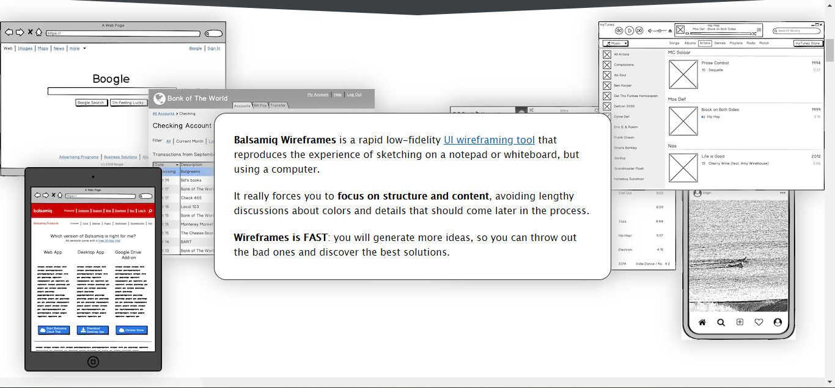

* **VS code** for writing HTML and CSS as it is free of cost and open source software. It has many extensions which saves your time while writing code and makes the code visually appealing. It also has default extension emmet which helps you to write HTML faster which few words. It also auto-completes sentences based on context and offer many keyboard shortcuts out of the box and also allows you to edit or create new shortcuts as you see fit.



* **HTML, CSS** for basic structuring and designing the website.
* I used **JavaScript** to make the site interactive and add functionalities which are not available with just HTML and CSS.
* Twitter **Bootstrap** is another great CSS framework available out there. I integrated some of the bootstrap component in my website.

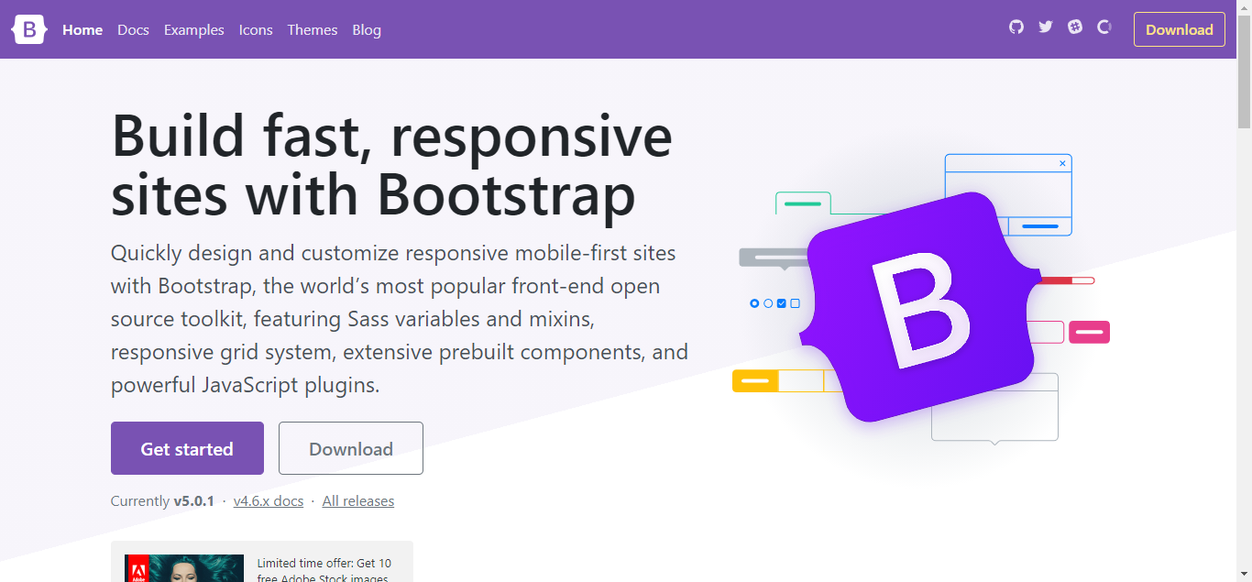

* The navbar is a **Bootstrap** component.



* I also used **JQuery** as it apply JavaScript for me with just a few lines and reduce the time and effort to write vanilla JavaScript. JQuery UI is also something that has been a lot of help to me as it allowed me to use awesome widgets in my website. One the feature I used from **JQuery UI** is its tab component. I didn’t have to write bulk of code as it was already written for me and I can just call the functions to set up the component.
* **Font awesome** was also used as it provides icons for your website for free. Icons make the website look more attractive.

# Bibliography

Cloudflare [WWW] What is DNS? [online] Available at: <https://www.cloudflare.com/en-in/learning/dns/what-is-dns/> [Accessed: 1 May 2021]

Wikipedia [WWW] Port [online] Available at: <https://en.wikipedia.org/wiki/Port_(computer_networking)> [Accessed: 1 May 2021]

Wikipedia [WWW] Types of Protocols [online] Available at: <https://en.wikipedia.org/wiki/Lists_of_network_protocols> [Accessed: 1 May 2021]

Wikipedia [WWW] Comparison of Web Server Software [online] Available at: <https://en.wikipedia.org/wiki/Comparison_of_web_server_softwares> [Accessed: 18 May 2021]

Quora [WWW] What is impact of React JS on web design [online] Available at: <https://www.quora.com/What-is-the-impact-of-ReactJS-on-website-design> [Accessed: 18 May 2021]

99designs [WWW] Graphic design trends [online] Available at: <https://99designs.com/blog/trends/graphic-design-trends/> [Accessed: 18 May 2021]